Maths alternative 1- o’clock and half past
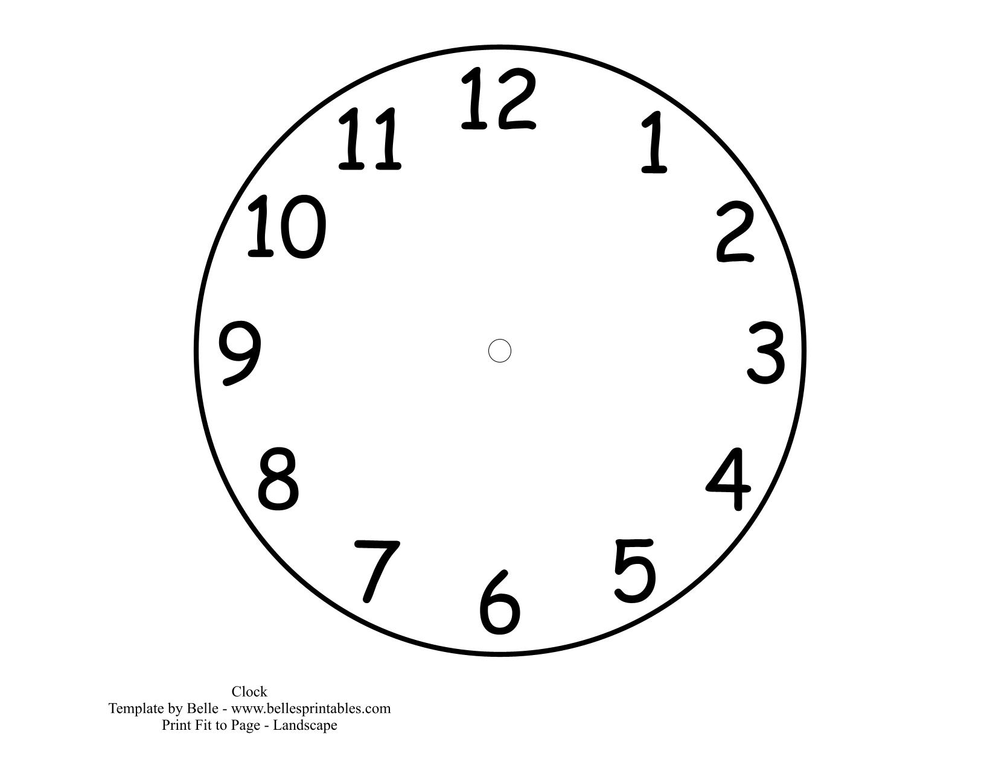
__ o’clock
Half past __
Half past __

Half past 2
4 o’clock
Half past 5

Draw your own hands on the clock and then write the times.

