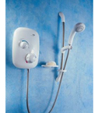 | 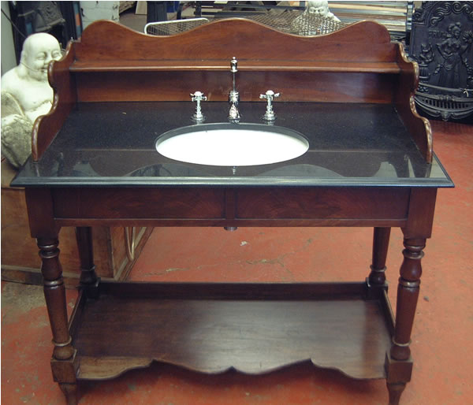 | 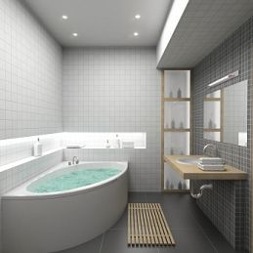 | 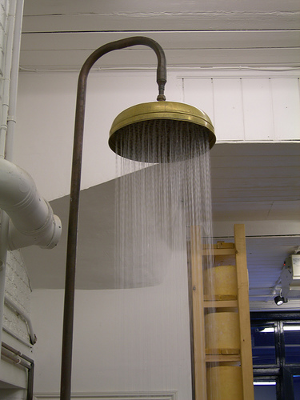
Alternative learning – History

Look at the images below. Sort them into past (old) and present (new) objects. What makes the objects old or new? Write key words to explain.

Past (old) objects |  | Present (new) objects

