Maths Learning Intention - To answer word problems relating to addition and subtraction.

Q1.
The numbers in this sequence increase by 45 each time.
Write the missing numbers.

Q2.
Write the missing digits to make this addition correct.

Q3.
John buys one toy car and one pack of stickers.

£1.49 £1.64
He pays with a £10 note.
How much change does John get?

Q4.
Ken is playing a game. He has 4,289 points.
Then he scores another 355 points.
Ken’s target is 6,000 points.
How many more points does Ken need to reach his target?

Q5.
Write the three missing digits to make this addition correct.
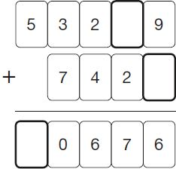
Q6.

Complete this table with the missing numbers.
One row has been done for you.

Number | 1,000 more
3,500 | 4,500
85
 | 9,099
 | 15,250

