English Learning Intention – To read a text and answer comprehension questions.

Michael is a young fisherman. He often takes out his boat, the ‘Louisa May’, for a day of fishing.
An Encounter at Sea
It was hot. Really hot. There wasn’t the slightest breeze to cool the skin or make even a baby-finger crease on the surface of the sea. The Louisa May floated like a toy sitting on a glass table.
For the first time in over a week, Michael hadn’t seen a dolphin all day. He was two miles offshore now, motoring along his daily survey course. The Louisa May pulled the reflection of the sky and the island into pleats behind her, and the putt-putt of her engine was lost in the big, quiet stillness of the afternoon.
Michael shut off the outboard motor and stopped. He leaned over the side to scoop up a bucket of seawater to cool himself, and looked down. Long fingers of sunlight slanted into the clear water, shifting slightly in arcs of radiating lines, and were swallowed up at last into the perfect blueness of the depths.
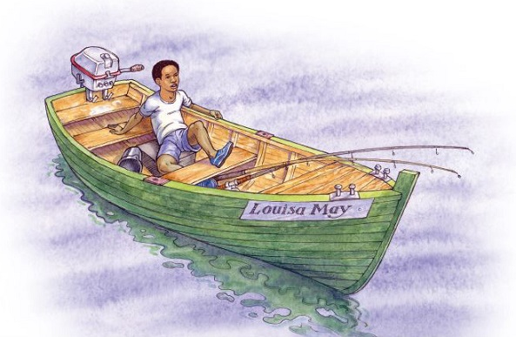
He poured the water over himself, savouring the delicious coolness.

Pppfffffwwwwraa! The sound came from close behind him, and made him spin round so fast he lost his balance and fell into the bottom of the boat.
Pppfffff – shorter and louder, even closer.
Michael picked himself up and looked over the side.
A black shape, much, much bigger than the biggest dolphin, showed about five metres from the boat. It was like a polished rock. On its rounded side was a slit like a flattened S, bigger than a man’s two clenched fists, with a raised lip around it. As Michael watched, astonished, not understanding what he was seeing, the lips pinched together, the hole closed, and the black shape sank rapidly beneath the sluicing water.
A whale! Its dark head and blowhole! That’s what he had seen.
Pppfffffwwwwraa!
Now it had surfaced on the other side of the boat. This second surfacing was hardly less shocking than the first, although Michael just managed to stay on his feet and cross the boat this time.
Carefully, Michael leaned over to look: on one side of the boat lay the whale’s tapering tail; on the other side, the head with its scarred lines lay like a piece of huge, dark wreckage. This close, Michael could see that big sections of skin had peeled off in straight lines, giving the whale’s head a patchwork look in greys and blacks. Closest of all to the boat, only just submerged, was the whale’s eye. Michael looked right into it, and the whale looked back. It was so very, very close. He leaned out further and further, stretching his hand slowly towards it. The whale didn’t draw away.
He reached down, until his fingertips touched the crease of skin that gave the whale a kind of eyebrow. It was cool and smooth, like a carved stone covered in a finely stretched coat of rubber.
And as his fingertips touched the whale, he looked into its eye. It was impossible to say what colour it was: dark but with rays of brightness. It was like a window into a whole galaxy, with stars and planets, comets and supernovae moving inside.
Effortlessly, as if movement and thought were the same thing, the whale submerged out of reach of Michael’s hand. There was a last shushing sigh as the flipper caressed the boat one more time, and then they were separate again.
The setting sun made a path over the sea, bathing Michael in golden light. He felt as if he were lit up inside too. He had touched a whale and looked into its eye! Like a sleeper waking from a dream, he looked around, dazed.
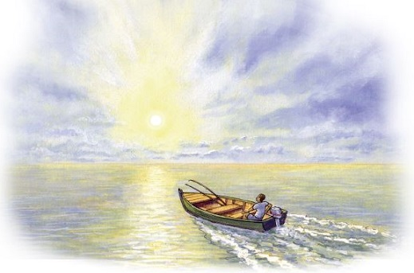

1. ...like a toy sitting on a glass table.
What does this description suggest about the boat?
_____________________________________________________________

2. Look at page 1.
What was unusual for Michael about this day?
______________________________________________________________
______________________________________________________________

3. ...the ‘putt-putt’ of her engine was lost in the big, quiet stillness of the afternoon.
Choose the best words to match the description above. Circle both of your choices.
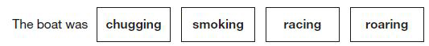
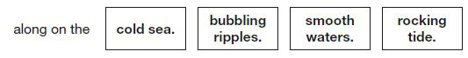
4. Look at page 1.
Find and copy two different words that show Michael enjoyed the feeling of the cool water.
1. ____________________________________
2. ____________________________________
5. Look at page 2.
How is the whale made to seem mysterious?
Explain two ways, giving evidence from the text to support your answer.
______________________________________________________________
______________________________________________________________
______________________________________________________________
______________________________________________________________
______________________________________________________________
______________________________________________________________
_____________________________________________________________

6. When Michael touched the whale it felt smooth.
(a) According to the text on page 2, why might he have expected it to feel smooth?
_________________________________________________________
_________________________________________________________
(b) According to the text on page 3, why might he not have expected it to feel smooth?
_________________________________________________________
_________________________________________________________
7. Look at the paragraph beginning: Carefully, Michael leaned...
Where was the whale?

 | Tick one.
in front of the boat | 
at the side of the boat
under the boat
five metres from the boat
8. Look at the paragraph beginning: Carefully, Michael leaned...
What does this paragraph tell you about Michael’s character?
Explain two features of his character, using evidence from the text to support your answer.
______________________________________________________________
______________________________________________________________
______________________________________________________________
______________________________________________________________
______________________________________________________________
______________________________________________________________
______________________________________________________________
9. The whale did not seem to be alarmed by meeting Michael. How can you tell this from its actions?
Give two ways.
1. ____________________________________________________________
2. ____________________________________________________________
10. Like a sleeper waking from a dream, he looked around, dazed.
This tells us that at the end of the story Michael felt that...

Tick one.
he wanted the experience to continue.
he had experienced something similar before.
the experience was unreal.
the experience was worrying.
11. Tick one box in each row to show whether each statement is true or false.

 | True | False
Michael was in an unfamiliar area of sea when he saw the whale.
The boat was still motoring forwards when the whale appeared.
The whale felt warm and soft when Michael touched it.
Michael could not name the colour of the whale’s eye.

