English Intention – To read the text and answer comprehension questions.

I'm Riding on a Giant
I'm riding on a giant.  I’m way up in the sky.  Looking down on everyone.  From higher up than high. | 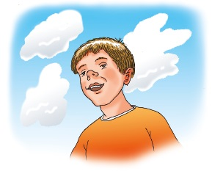
(a) What does the child say they are riding on?
Tick one.

a cloud |  | a giant
a horse |  | a train
(b) Who is the child looking down on?
______________________________

I’m holding on to giant’s ears  As we stride along the street  Shouting down at people,  “Hey! Mind my giant’s feet!”  We’re ducking down through doorways.  We’re walking over walls.  I’m safe as houses way up here.  My giant never falls. | 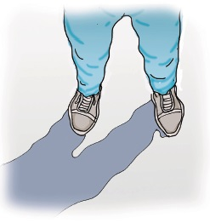
1 What is the child holding on to?
______________________________________________________________
2 As we stride along the street
Which word means the same as stride?
Tick one.

crawl |  | march
dance |  | climb

People down below us  Simply stop and stare.  Then when they see our shadow,  Oh wow! They get a scare.  I’m taller than the tree-tops.  I’m high enough to fly.  Another centimetre and I’d  Bump into the sky. | 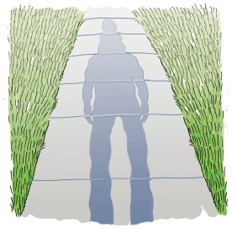
3 What happens when people see the shadow?
______________________________________________________________

I’ve been riding on my giant,  Oh! What a day I’ve had.  I’m not afraid of giants,  ‘Cause this one is my dad. | 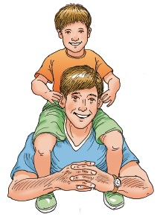
4 Why did the child describe their father as a giant?
______________________________________________________________
5 Which of these do you think the child is likely to say at the end of the outing?

Tick one.
That was fun, Mum. Can you do it all over again?
That was so scary. I never want to do it again!
That was really boring, Dad.
That was great, Dad. Let’s do it again!

