Moorside Community Primary School

Newsletter



**Moorside Community Primary School**

*Diary Dates – October 2017*

**Family Learning**

***Tuesday*** - 9.15-11.15 Story Sacks for parents/carers of Nursery and Reception classes.

***Wednesday***- 9.15 -11.15 Phonics Read Write Inc. for parents/carers of Reception classes.

***Thursday*** - 13.15-15.15 Family Language.

*Tuesday: Samba – Y6*

*Wednesday: Trumpets – Y4*

*Thursday: Swimming – Y3*

Macmillan Coffee Morning – Well done to Year 6 for organising a fantastic coffee morning to raise money for such a worthwhile charity. In total we raised £188. Thank you to all parents, carers and pupils who donated money and attended our coffee morning. We hope you enjoyed it!

Volleyball – Last Thursday, we had a very exciting morning with an Olympic volleyball player Peter Bakare. He pushed us all to our limits by encouraging us to do a range of circuit style fitness activities: push ups, star jumps, spotty dogs and leg drives.

A special thank you to our fitness motivators, who did an excellent job helping and encouraging all pupils during the activities. Peter and Chris were very impressed!

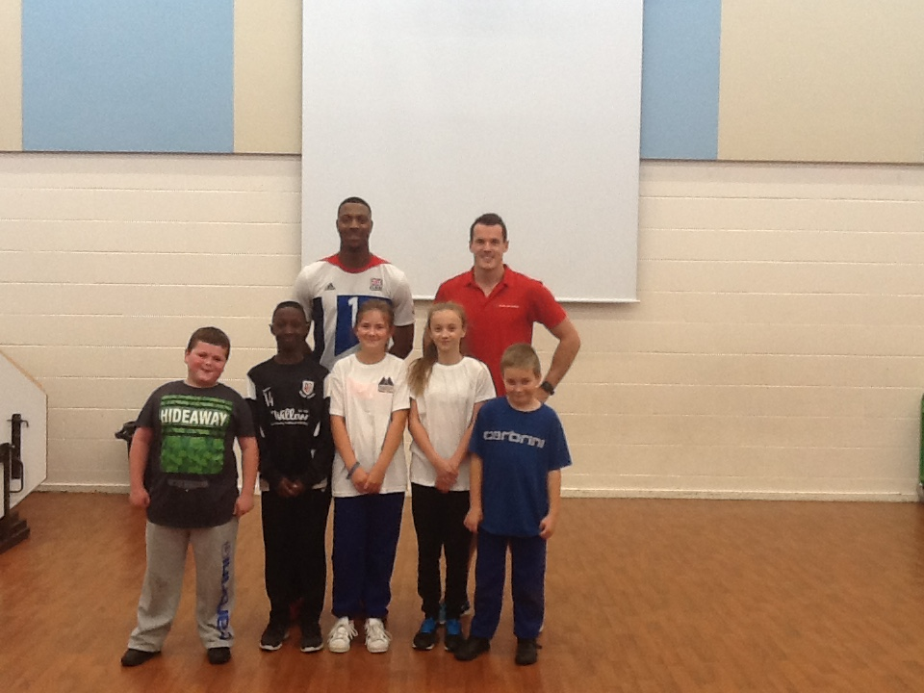

**w/c 25th September 2017**

Well done to 3R for achieving **100%** attendance!

Attendance w/c 25/09/2017:

|  |  |
| --- | --- |
| Class | Attendance |
| RC | 85.7% |
| RW | 94.3% |
| 1C | 95.0% |
| 1CS | 96.3% |
| 1L | 91.0% |
| 2A | 96.9% |
| 2J | 95.9% |
| 3G | 96.2% |
| 3R | **100%** |
| 4L | 92.1% |
| 4P | 85.2% |
| 5S | 98.8% |
| 5W | 97.4% |
| 6B | 90.0% |
| 6R | 96.1% |
| 6W | 97.8% |

We have had a great start to the academic year and attendance has started off well. It is very important pupils maintain a high attendance to ensure they are accessing all of their learning opportunities.

Each week the teachers from Reception to Year 6 classes will select a child that they believe has worked really hard that week, has carried out something special or been exceptionally kind to someone. We will then share this in assembly on a Monday with others and present them with a certificate to acknowledge their hard work. Then throughout the rest of the week they will lead their class in and around school.

* **Omar Khattab** for settling in so well to his new school
* **Ollie Russell** for excellent handwriting and remembering to write his name on his work
* **Hashir Saleem** for excellent listening all week
* **Emily Johnson** for great listening and sharing new ideas
* **Fatimah Buobaid** for fantastic recall of Hansel and Gretel
* **Limar Khattab** for trying her best all week and sharing good ideas
* **Alaa Aref** for using expanded noun phrases independently in her writing
* **James Yearnshire** for trying really hard to improve his writing
* **Naseer Ali** for working hard when reading his new books
* **Yousif Al-Kaltakchi** for fantastic geographical knowledge
* **Lucas Mitas** for always listening and trying really hard in maths
* **Alexander Pitman** for consistently good work in English and for being a great example to others
* **Lola Pears** for being a great class role model
* **Sumiya Begum** for working hard in maths to work through place value problems independently
* **Ali Al Hasan** for using inference skills to work out who Jane Austen was
* **Diyar Ali Arif** for improving his presentation in maths and for his great knowledge about World War 2.

**Stars of the Week!**

**w/c 2nd October 2017**

**Stars of the Week!**

* **Michelle Ruan** for being a good friend and always setting a good example.
* **Jibraeel Ahmed** for giving good answers during circle time.
* **Alauddin Abdul Muiz** for working hard all week.
* **Ibrahim Ahmed** for great maths problem solving.
* **Nikolina Marinkovic** for being enthusiastic in all lessons.
* **Rahaf Kashada** for a brilliant innovated Pied Piper story.
* **Tahsin Hoque** for trying her best in all she does and improving every week.
* **Wonder Alexander** for amazing cursive hard writing.
* **Sophia Danova** for being a supportive peer.
* **Jessica Ojariafe-Anthony** for trying really hard with her reading.
* **Rahad Haider** for excellent maths problem solving.
* **Rehan Rahman** for a great improvement in maths work.
* **Akmal Sultan** for keeping our area a clean, safe working area.
* **Sharon Vincent Isaac** for using a range of sentence structures in her writing.
* **Yasmin Tairou-Katakpaou** for being brave in maths and trying new skills with confidence.
* **Hajirah Noor** for trying really hard at long multiplication.

Attendance w/c 02/10/2017:

|  |  |
| --- | --- |
| Class | Attendance |
| RC | 87% |
| RW | 84.3% |
| 1C | 91.1% |
| 1CS | 96.8% |
| 1L | 98% |
| 2A | 94.9% |
| 2J | 98% |
| 3G | 96.2% |
| 3R | 94.3% |
| 4L | 91.7% |
| 4P | **99.2%** |
| 5S | 98% |
| 5W | 98.5% |
| 6B | 90.9% |
| 6R | 97.8% |
| 6W | 94.4% |

We have had a great start to the academic year and attendance has started off well. It is very important pupils maintain a high attendance to ensure they are accessing all of their learning opportunities.

Well done to 4P for achieving **99.2%** attendance.