Alternative English Learning Intention – To read a fictional text and answer retrieval questions.
Read the text called ‘Little Cousin Clare.’ Answer the questions below.
When Bryn heard that his little cousin, Clare, was coming to visit, he was very excited. He lived on a farm, a long way from the nearest village, and he didn’t have any brothers or sisters.

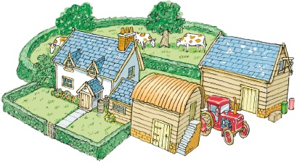
(a) What is the name of the boy who lived on the farm?
______________________________
(b) How did he feel about his cousin visiting?
Tick one.

worried |  | surprised
happy |  | angry

Bryn got out all his trucks and cars and arranged them in a line. He decided Clare could choose first which to play with, although he couldn’t help hoping it wouldn’t be the big, blue one.  “I’m glad to see you’re tidying up, Bryn,” said Dad. “Your room looks much better now.” | 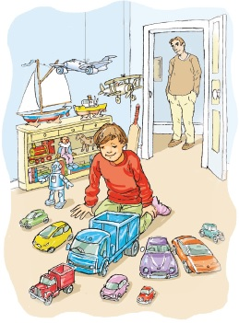
1 Why did Bryn get out his toys?

Tick one.
He was deciding which one to play with.
He wanted to hide them from Clare.
He wanted to tidy them away.
He was getting them ready for Clare.
2 What did Dad say looks much better now?
______________________________

But Bryn hadn’t finished. He started to sort out his books and put all the ones about animals together and all the ones about trucks together. He wondered if Clare would like different kinds of books, as she was a girl, but he couldn’t imagine anyone not liking animals and trucks. After all, his mother was always driving big tractors on the farm. | 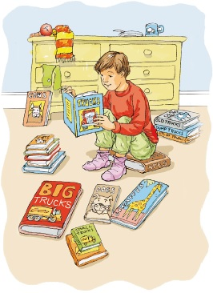
3 Which two topics did Bryn sort his books into?
1. ______________________________
2. ______________________________
4 Who drives the tractor on the farm?
Tick one.

Bryn |  | Bryn’s dad
Clare |  | Bryn’s mum
Bryn was too excited to eat much breakfast the next day. He was waiting for the sound of wheels in the driveway. When they came, Bryn hid behind his mother and tried to peep around her legs for his first sight of Clare. All he could see was a lady carrying something wrapped up in a blanket.
“Bryn,” smiled his mother, “this is Aunt Jo.”
Aunt Jo bent down. “And this is your little cousin, Clare,” she said.
Bryn looked right into the face of a tiny, sleeping baby.
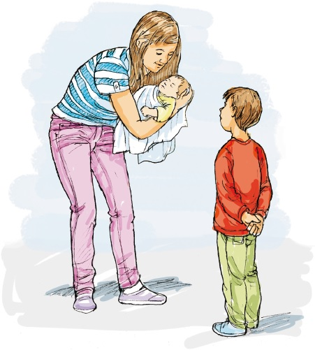
5 ...tried to peep around her legs...
What does this tell you about Bryn?

Tick one.
He did not want to see his cousin.
He was angry about the visit.
He was nervous about meeting Clare.
He did not like his cousin Clare.
6 Why was Bryn surprised when he met his cousin?
______________________________________________________________
“Excuse me,” he said. “I just have to put some things away.”
“He’s been very tidy recently,” his mother told Aunt Jo. “He’s growing up so fast.”
As Bryn put away his trucks and his books, he didn’t really feel bad that Clare couldn’t play with them. It meant he had a little more time to have the big, blue truck all to himself. He would lend her his big, blue bear instead. After all, there’s nothing like a baby to make you feel much more grown-up than you’ve ever been before.
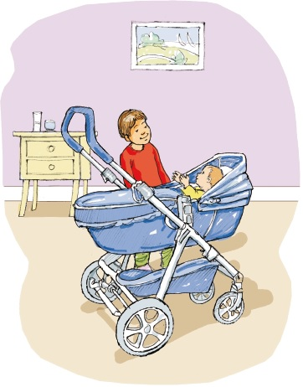
7 Why did Bryn put his toys away?
______________________________________________________________
8 What did Bryn decide to give Clare to play with?
______________________________
9 Think about the whole story.
Put ticks in the table to show which of these are true and which are false.
Sentence | True | False
Bryn liked to play with trucks.
Bryn’s mother worked on a farm.
Bryn lived in a village.

