Reading Learning Intention: To read a fictional text ‘Wild Ride.’

This story takes place in a huge grassland area in southern Africa. The grasslands there are called 'savannah'.
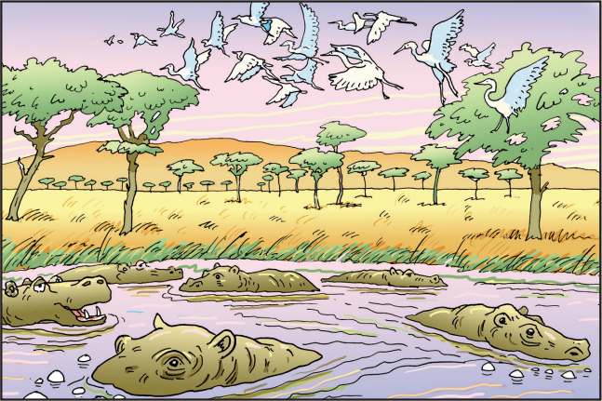
Dawn was casting spun-gold threads across a rosy sky over Sawubona Game Reserve as Martine Allen took a last look around to ensure there weren't any witnesses. She leaned forward like a jockey on the track, wound her fingers through a silver mane, and cried, 'Go, Jemmy, go.'
The white giraffe sprang forward so suddenly that she was almost unseated, but she recovered and, wrapping her arms around his neck, quickly adjusted to the familiar rhythm of Jemmy's rocking-horse stride. They swept past the dam and a herd of bubble-blowing hippos, past a flock of startled egrets lifting from the trees like white glitter, and out onto the open savannah plain. An early morning African chorus of doves, crickets and go-away birds provided a soundtrack.
For a long time Martine had only ever ridden Jemmy at night and in secret, but when her grandmother had found out about their nocturnal adventures she'd promptly banned them, on the grounds that the game reserve's deadliest animals were all in search of dinner after dark and there was nothing they'd like more than to feast on a giraffe-riding eleven-year-old. For a while Martine had defied her, but after several close calls and one terrible row with her grandmother, she had come to accept that the old lady was right. When lions were on the hunt, the game reserve was best avoided.
Another of her grandmother's rules was that Martine ride sedately at all times. 'No faster than a trot and, in fact, I'd rather you stuck to a walk,' she'd counselled sternly.
Martine had paid almost no attention. The way she saw it, Jemmy was a wild animal and it was only fair that he should have the freedom to do what came naturally, and if that meant tearing across the savannah at a giraffe's top speed of thirty-five kilometres per hour, well, there wasn't a lot she could do about it. It wasn't as if she had reins to stop him. Besides, what was the point of riding a giraffe if the most he was permitted to do was plod along like some arthritic pony from the local stables?
Jemmy clearly agreed. They flew across the grassy plain with the spring breeze singing in Martine's ears. 'Faster, Jemmy!' she yelled. 'Run for your life.' And she laughed out loud at the heart-pounding thrill of it, of racing a wild giraffe.

A streak of grey cut across her vision, accompanied by a furious, nasal squeal: 'Mmwheeeh!'. Jemmy swerved. In the instant before her body parted company with the white giraffe's, Martine caught a glimpse of a warthog charging from its burrow, yellow tusks thrust forward. Had her arms not been wrapped so tightly around the giraffe's neck, she would have crashed ten feet to the ground. As it was, she just sort of swung under his chest like a human necklace. There she dangled while Jemmy pranced skittishly and the warthog, intent on defending her young, let out enraged squeals from below. Five baby warthogs milled around in bewilderment, spindly tails pointing heavenwards. | 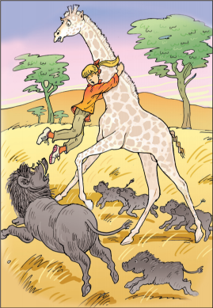
The pain in Martine's arms was nearly unbearable, but she didn't let go. She adored warthogs – warts, rough skin, ugly ears and all – but their Hollywood movie star eyelashes didn't fool her. In a blink of those lashes, their tusks could reduce her limbs to bloody ribbons.
'Jemmy,' she said through gritted teeth, 'walk on. Good boy.'
Confused, the white giraffe started to lower his neck as he backed away from the warthog.
'No, Jemmy!' shrieked Martine as the warthog nipped at the toe of one of her boots. 'Walk! Walk on!'
Jemmy snatched his head up to evade the warthog's sharp tusks, and Martine was able to use the momentum to hook her legs around his neck. From there, she was able to haul herself onto his back and urge him into a sprint. Soon the warthog family was a grey blur in the distance, although the mother's grunts of triumph took longer to fade.
Martine rode the rest of the way home at a gentle walk, a thoughtful smile on her lips. That would teach her to show off – even if it was only to an audience of hippos. At the game reserve gate, Jemmy dipped his head and Martine slid down his silvery neck as though she was shooting down a waterslide. That, too, wasn't the safest way of dismounting, but it was fun. She gave the white giraffe a parting hug, and strolled through the mango trees to the thatched house.

