Maths: To solve problems involving time

I left home at 5 past 2 and arrived at John’s house 25 minutes later. What time did I arrive at John’s house?
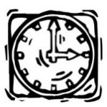
It is 3 o’clock. What time will it be in 45 minutes?

One Thursday it takes 10 minutes to take the class register. We started at 15 minutes past 1. What time did we finish?
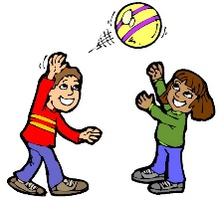
At a school playtime starts at 5 minutes past 10 and finishes at half past 10. How long is playtime?
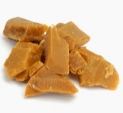
I start eating my toffees at 20 past 12 and it takes me 35 minutes to finish them. At what time did I finish?
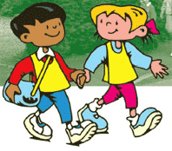
Amy started walking at 25 minutes past 8, she took 15 minutes to walk to school. What time did she arrive?
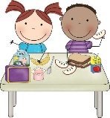
Children on packed lunches went in to the hall for their dinner at 12:30. They took 24 minutes to eat their dinner. What time did they finish?

Year 3 played a ukulele concert for their families at quarter past 2. The concert lasted 43 minutes. What time did it finish?

Challenge question
The children were allowed an extra-long lunchtime because they were so well behaved. Lunch started at 12 o’clock and finished at eight minutes past 1. How long did they have?

