Five a Day
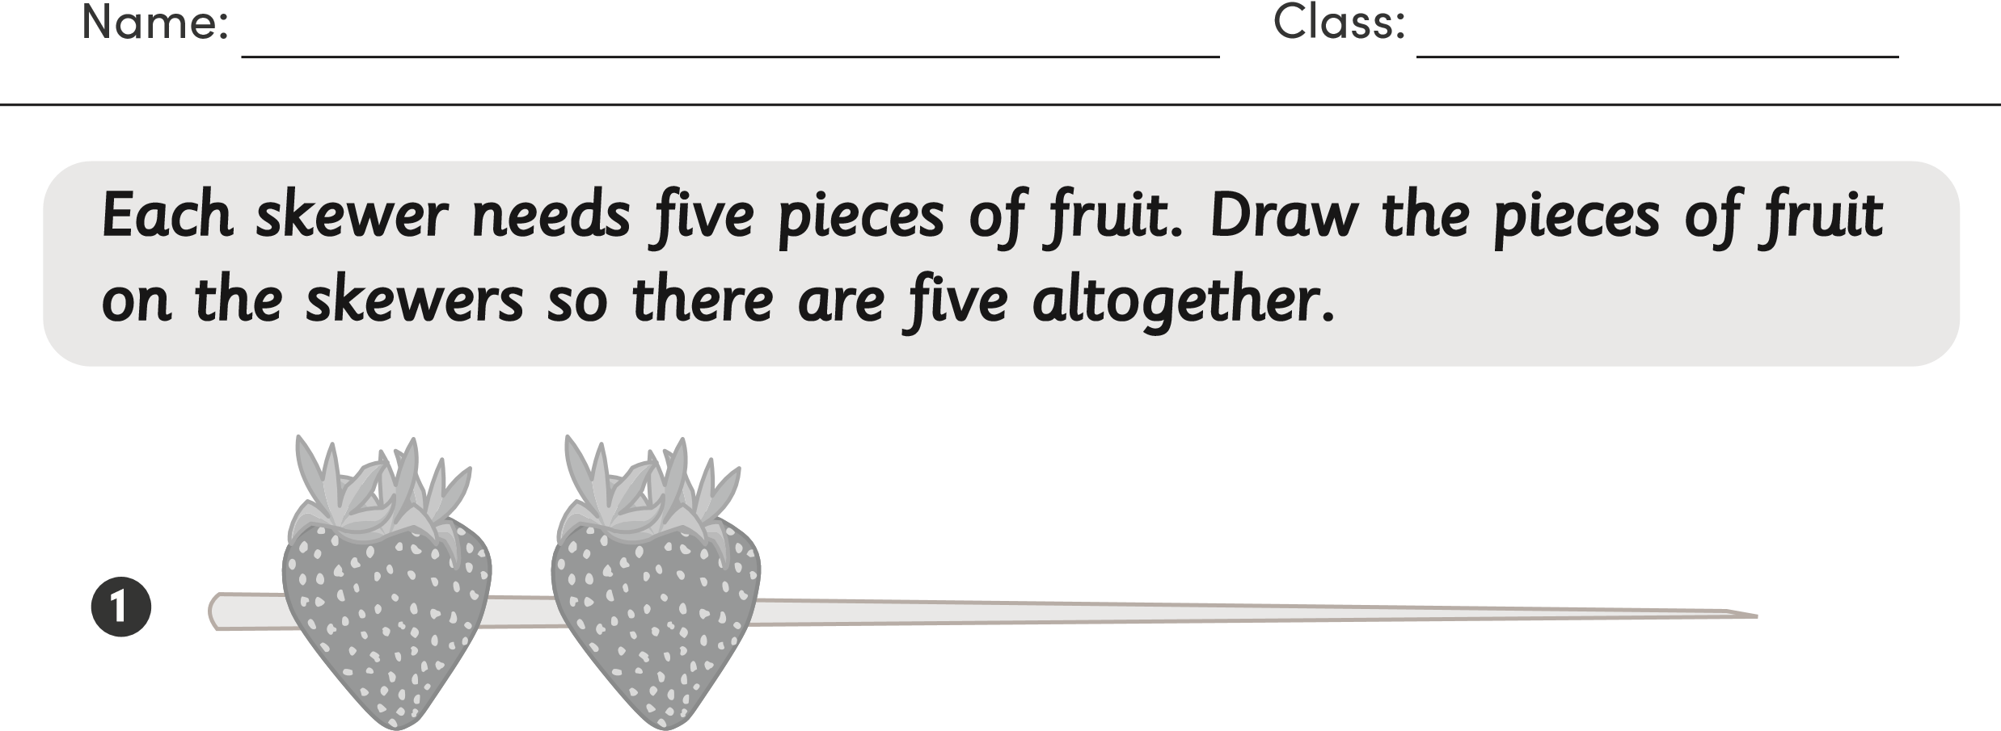
Activity Sheet
2
3
4
5

