Peter and the Wolf
Commentary

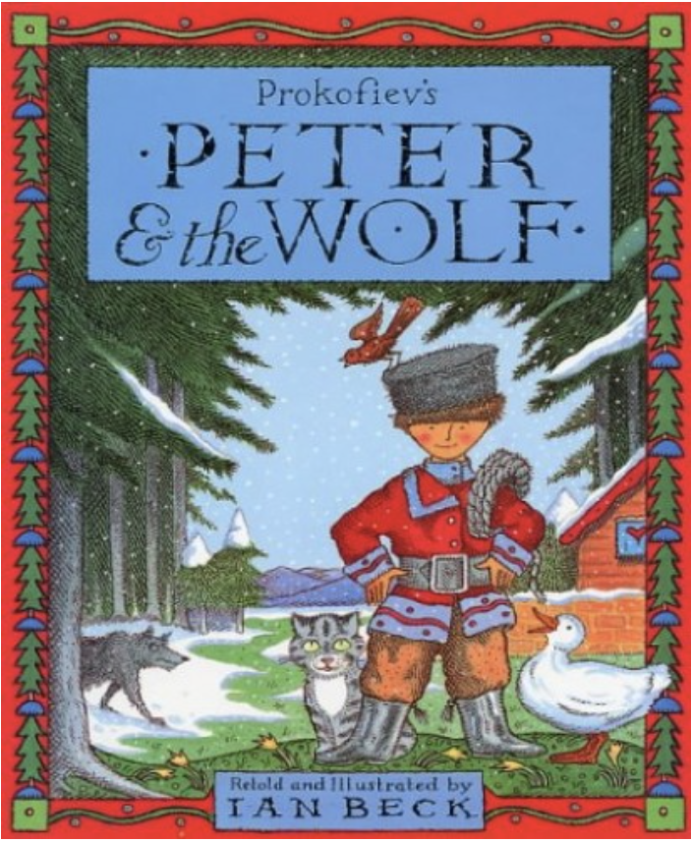 | First – Peter and the Wolf music  Then - Peter and the Wolf is a piece of music composed by Sergei Prokofiev in 1936, it has since been narrated, retold and illustrated by different authors. We will look at Ian Beck’s.
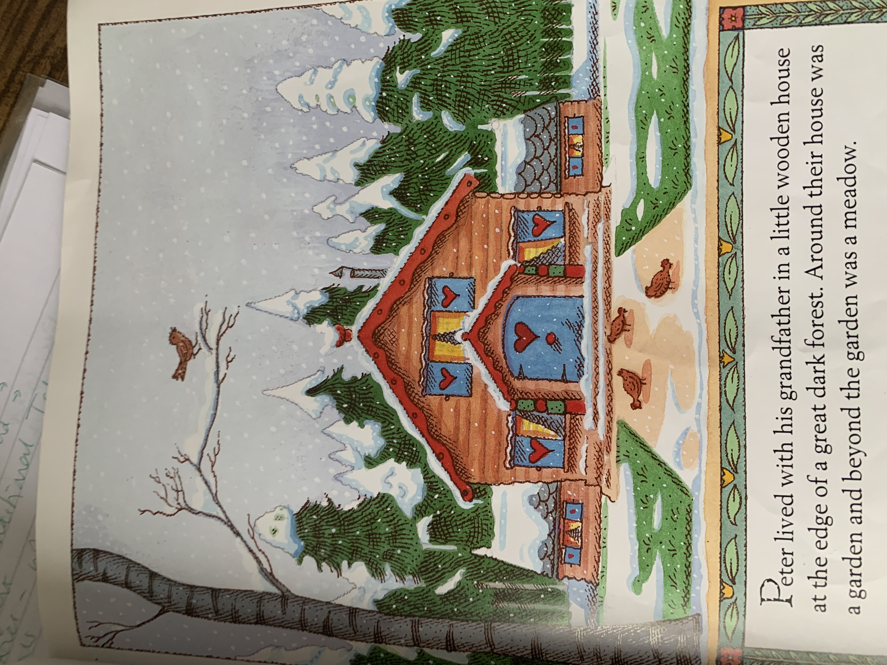 | Peter lived with his Grandfather in a little wooden house at the edge of a great dark forest. Around their house was a garden, beyond the garden was a meadow.
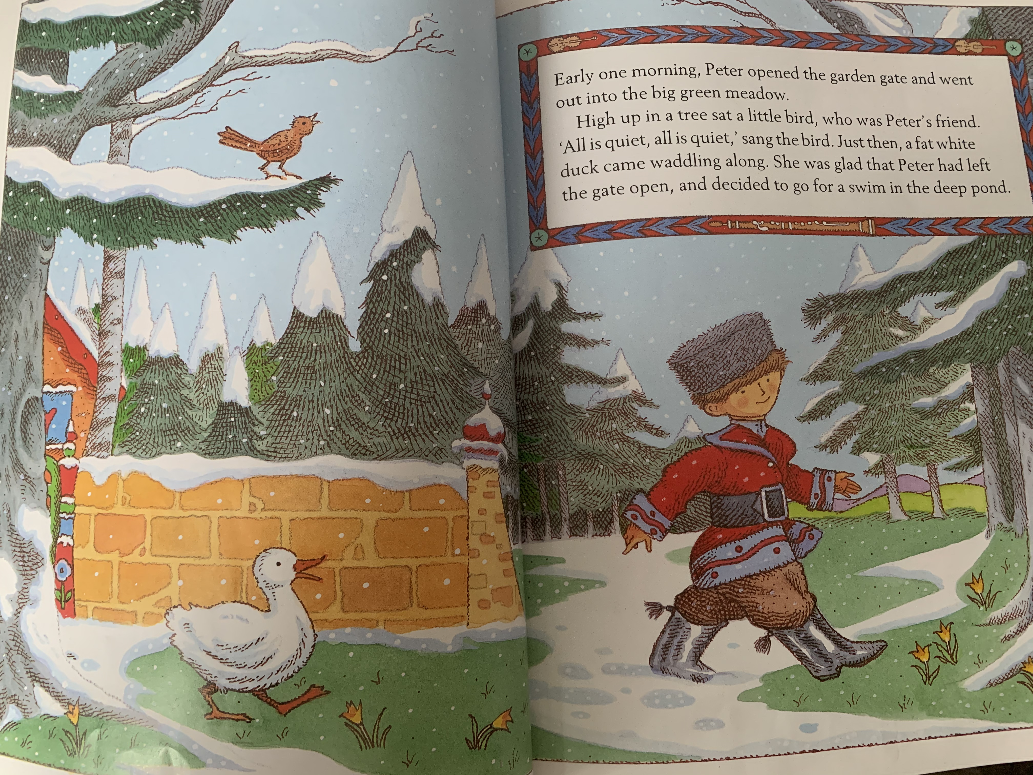 | Early one morning, Peter opened the garden gate and went out into the big green meadow. High up in the tree sat a little bird who was Peter’s friend. “All is quiet, all is quiet,” sang the bird. Just then a fat white duck came waddling along. She was glad that Peter had left the gate open and decided to go for a swim in the deep pond.
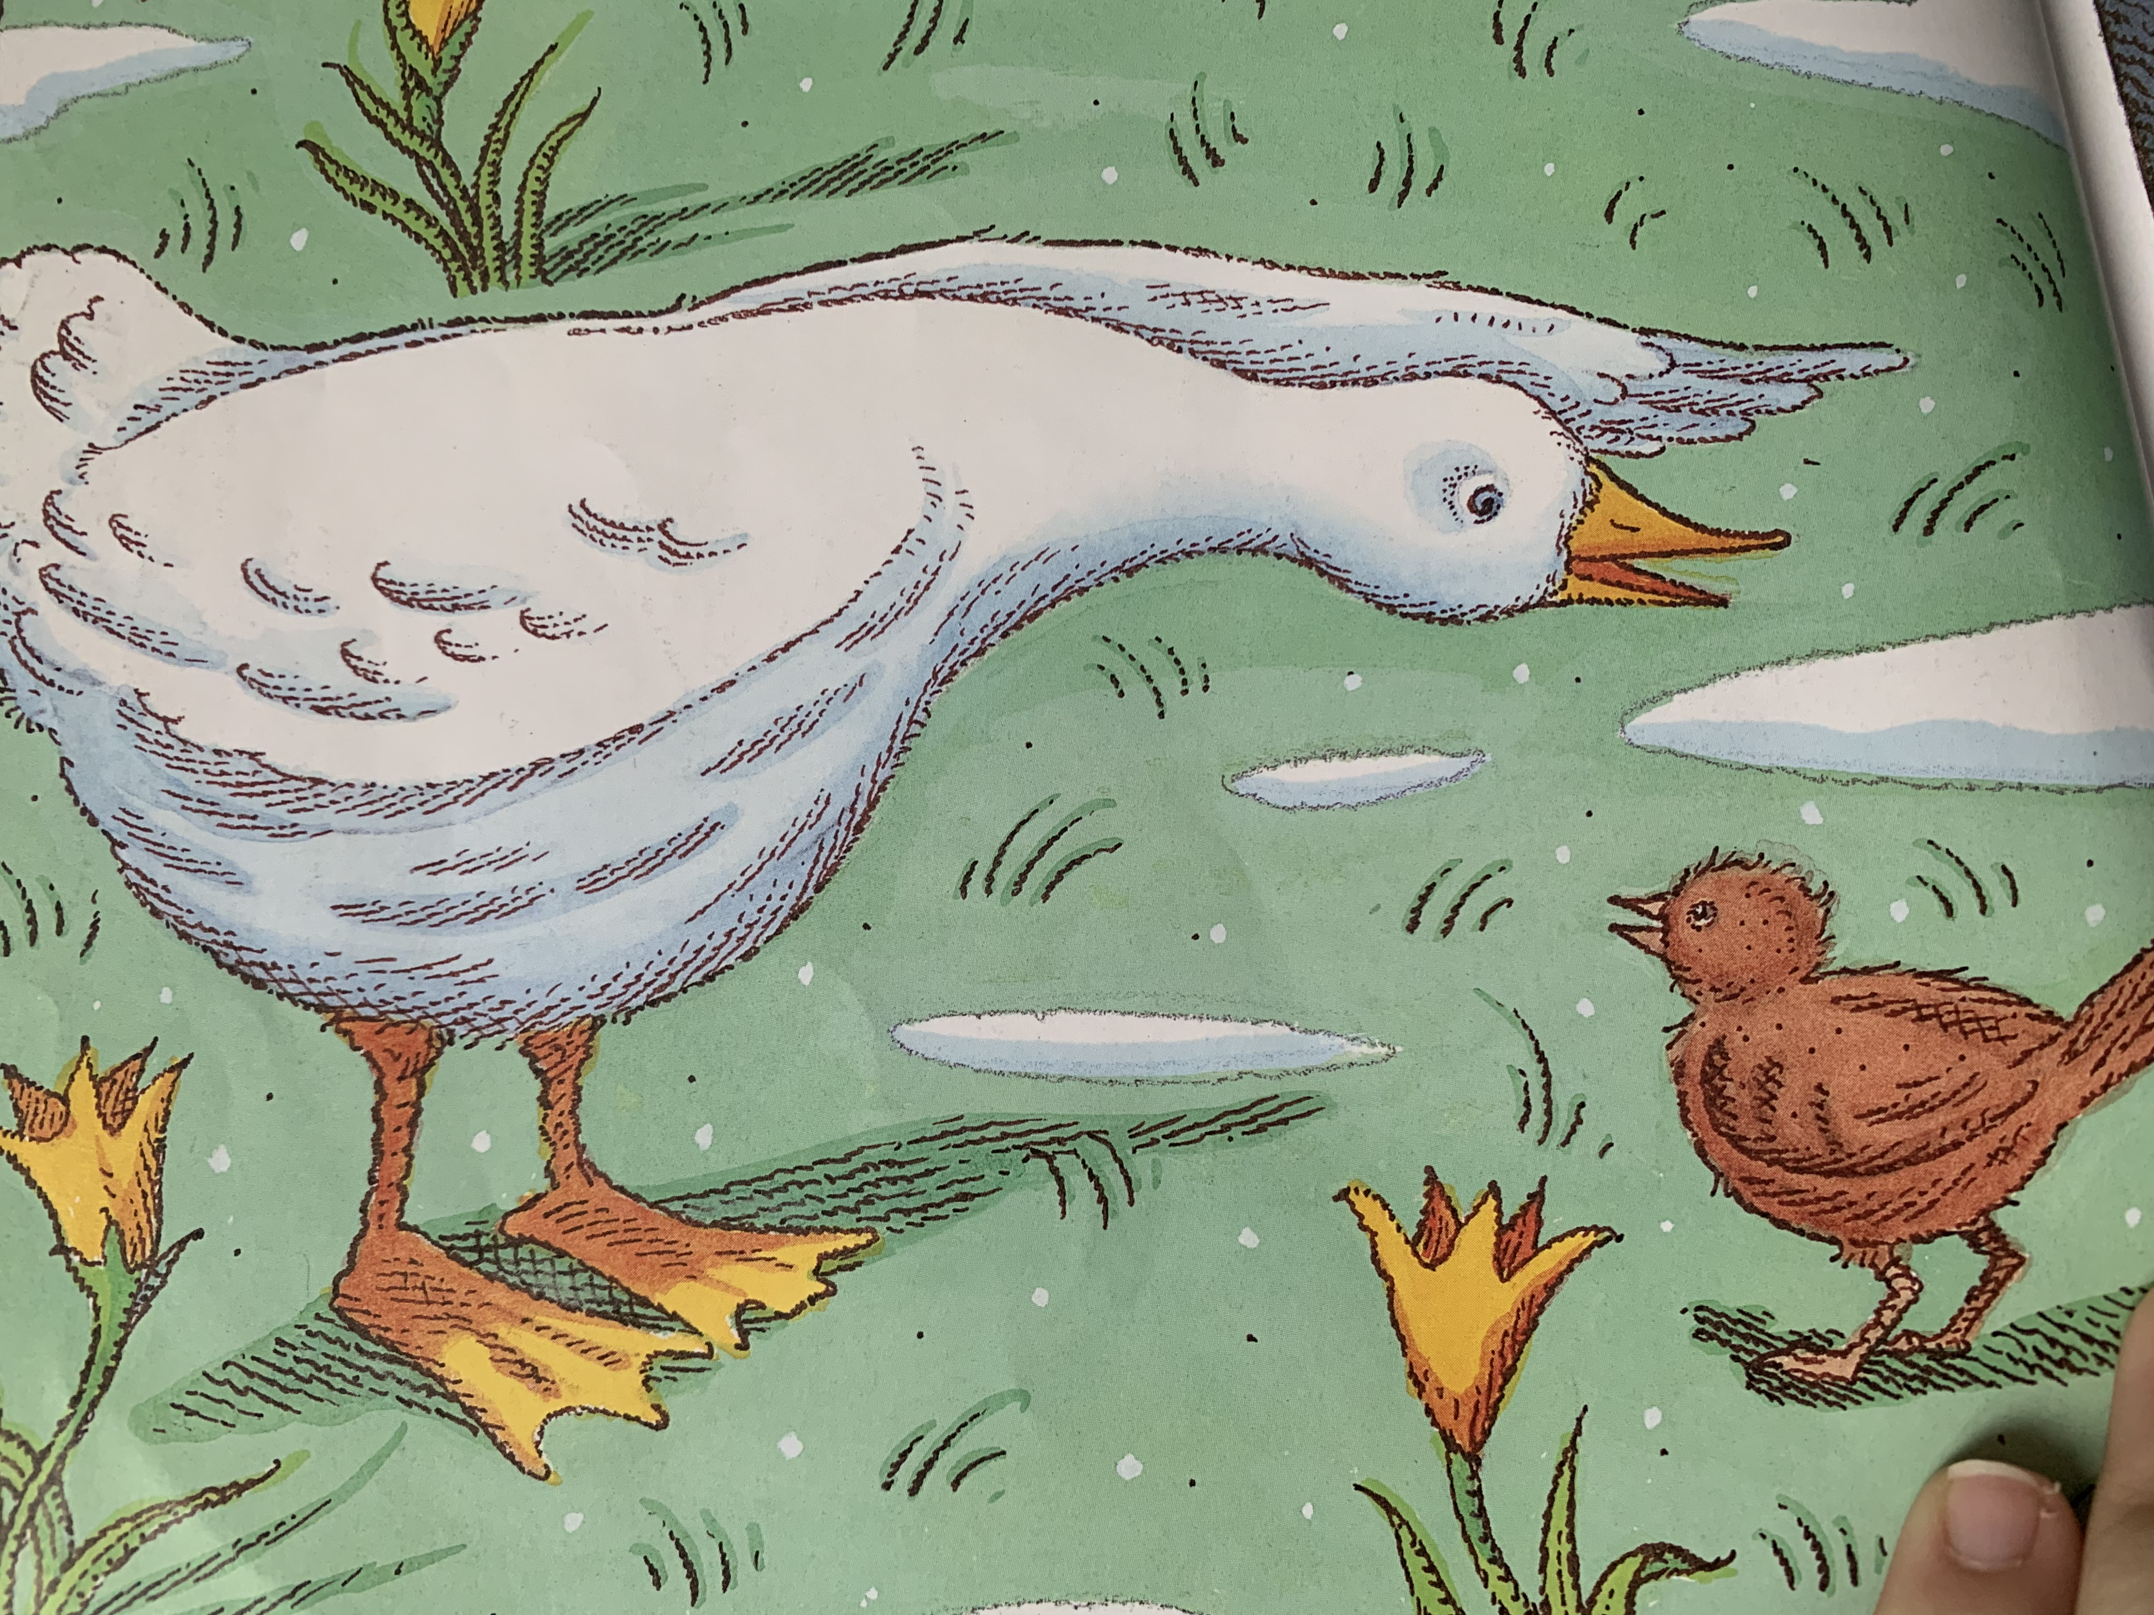 | Seeing the duck, the little bird flew down from the tree and settled next to her on the grass. He looked her up and down. “What kind of bird are you if you can’t fly?” He said.
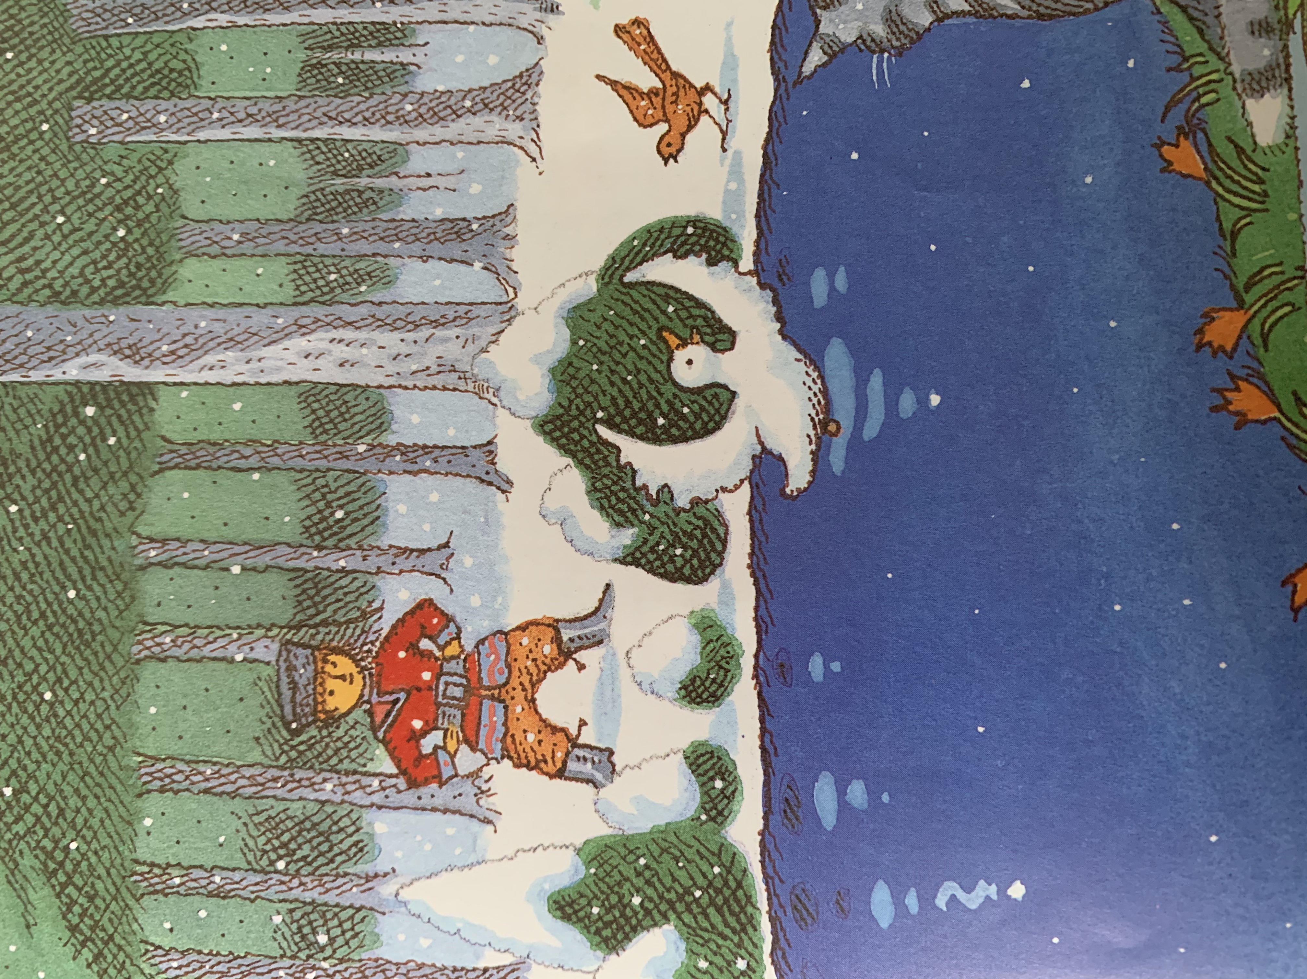 | The duck just shook her feathers and said, “What kind of bird are you, if you can’t swim?” She dived into the water. Peter watched them as they argued and argued. The duck quacking in the pond and the little bird hopping around the edge.
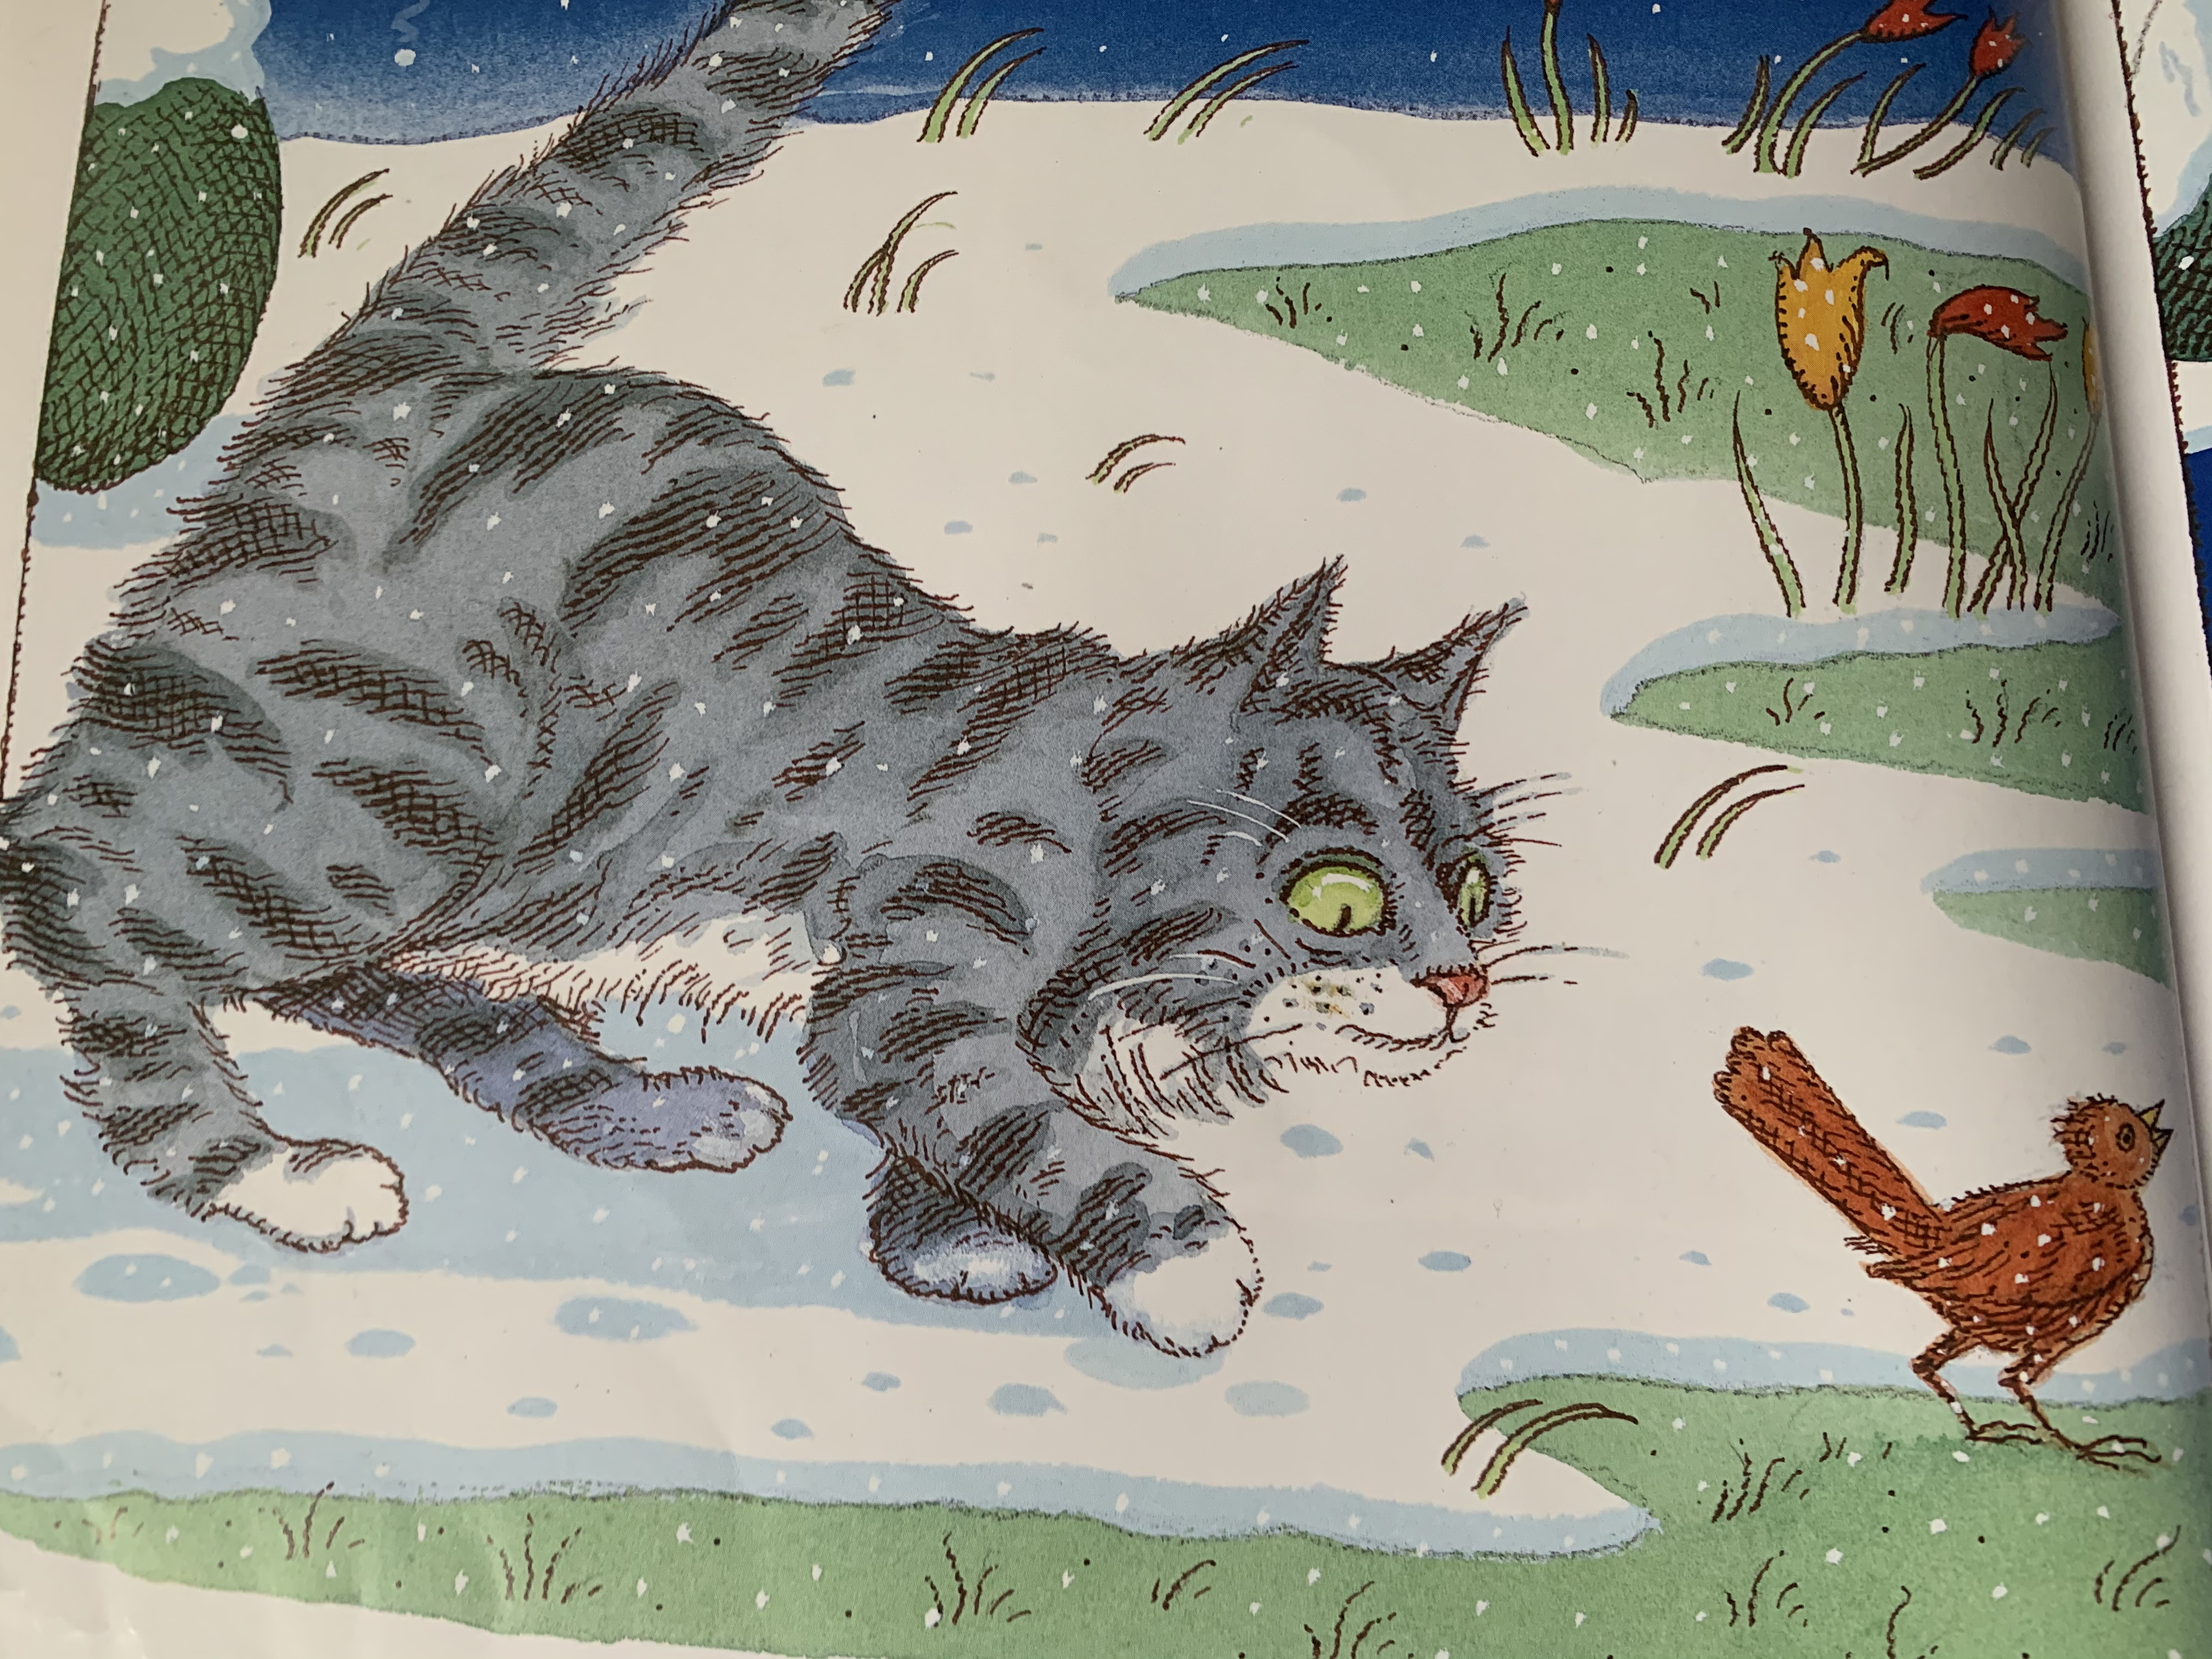 | Suddenly, something caught Peter’s eye. It was a cat, creeping slowly towards them. The cat was thinking, “While the little bird is so busy arguing with that duck, I’ll just grab him!” Stealthily she crept nearer and nearer on her soft velvet paws.
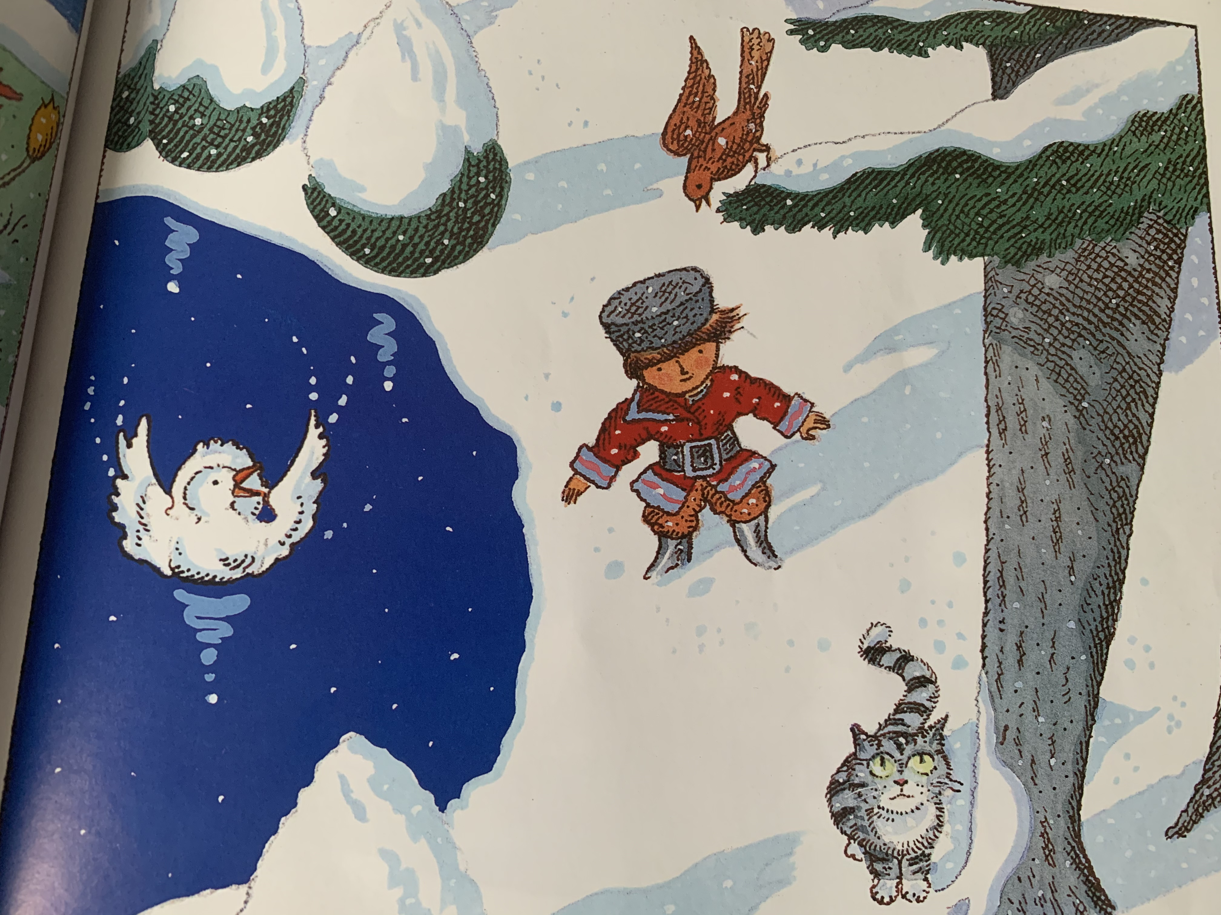 | “Look out!” Shouted Peter and the bird flew high into the tree while the duck quacked and flapped in the middle of the pond. The cat walked round and round the tree and thought, “Is it worth climbing up so high? By the time I get near the bird, he will have flown away!”
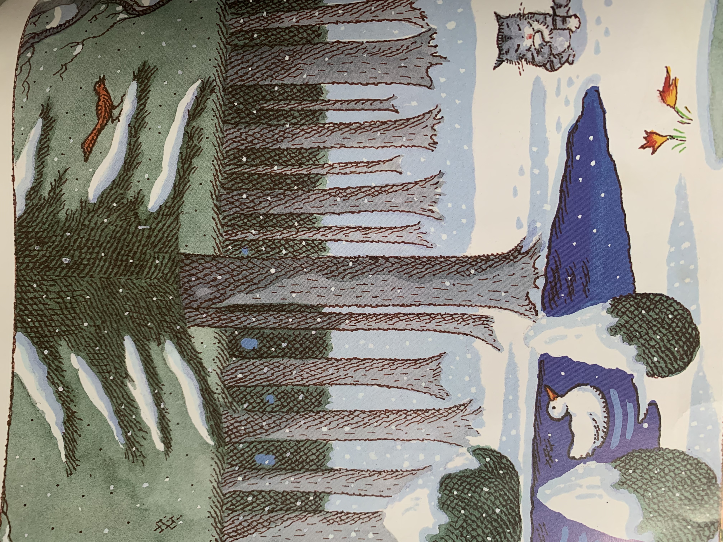 | Just then Grandfather came out of the house, he was angry that Peter had gone out into the meadow. “It’s a dangerous place this, suppose a wolf would come out of the great dark forest, what would you do then?!”
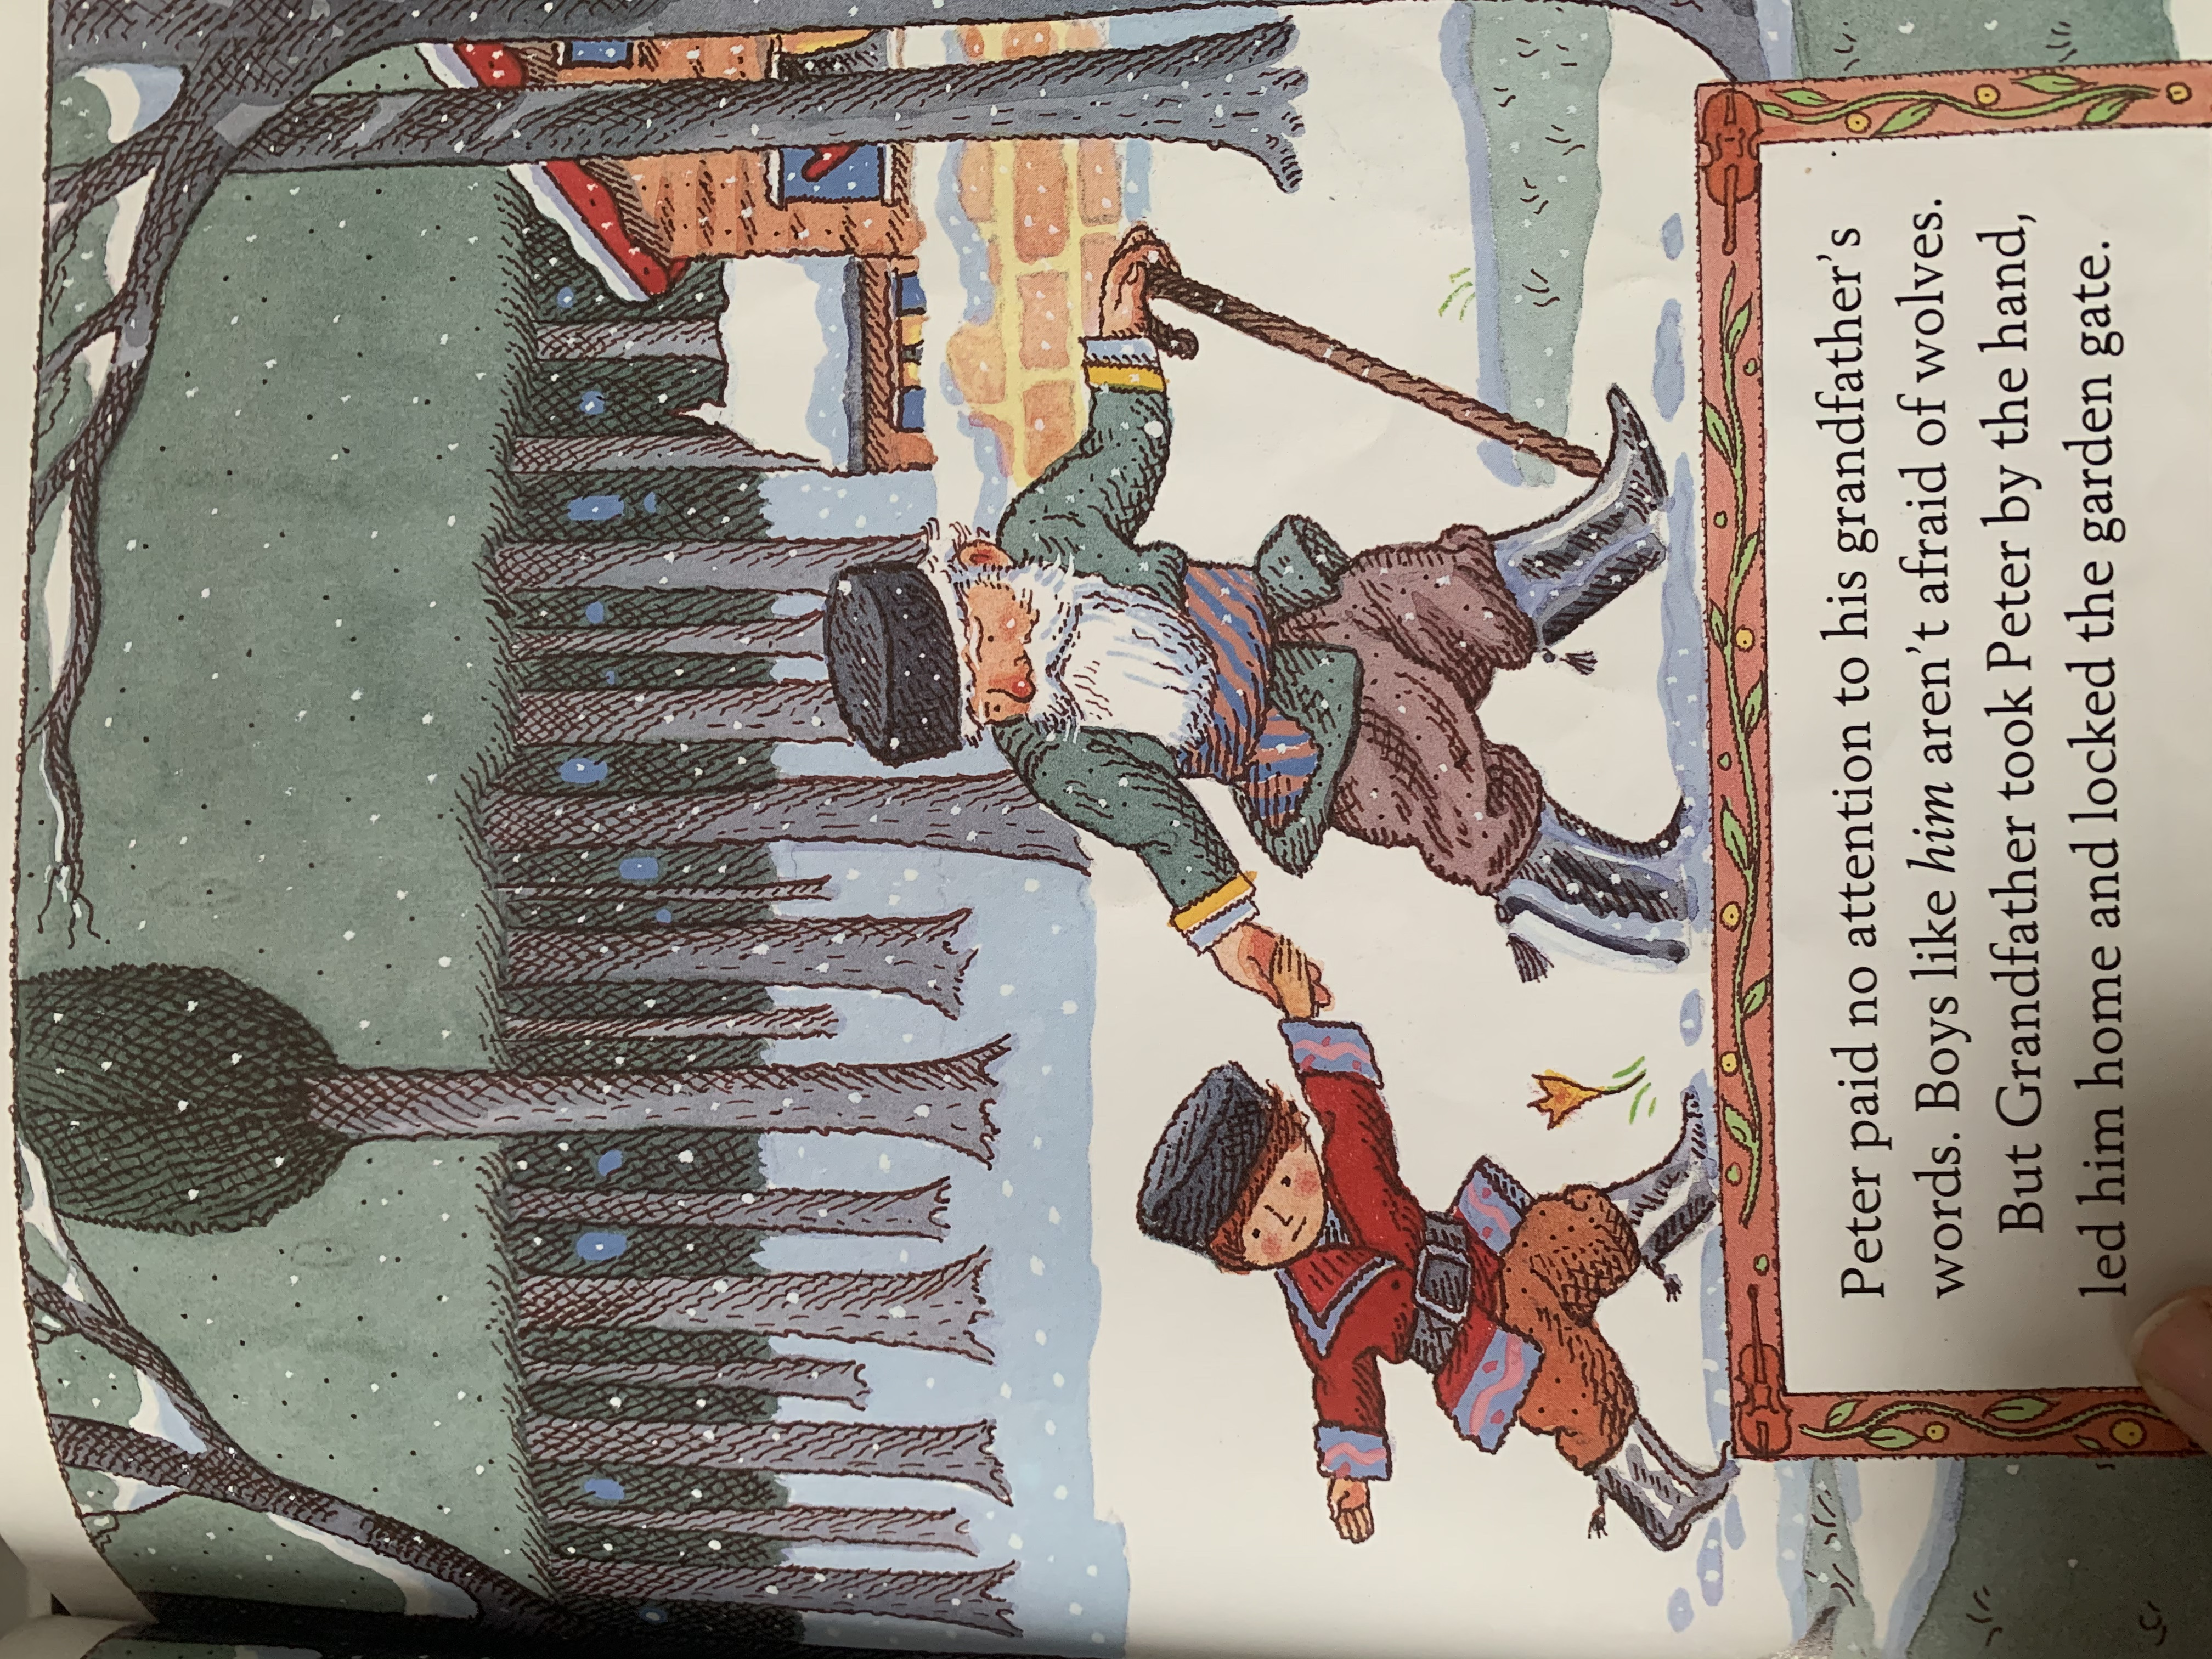 | Peter paid no attention to his Grandfather’s words. Boys like him aren’t afraid of wolves. Grandfather took Peter by the hand, led him home and locked the garden gate.
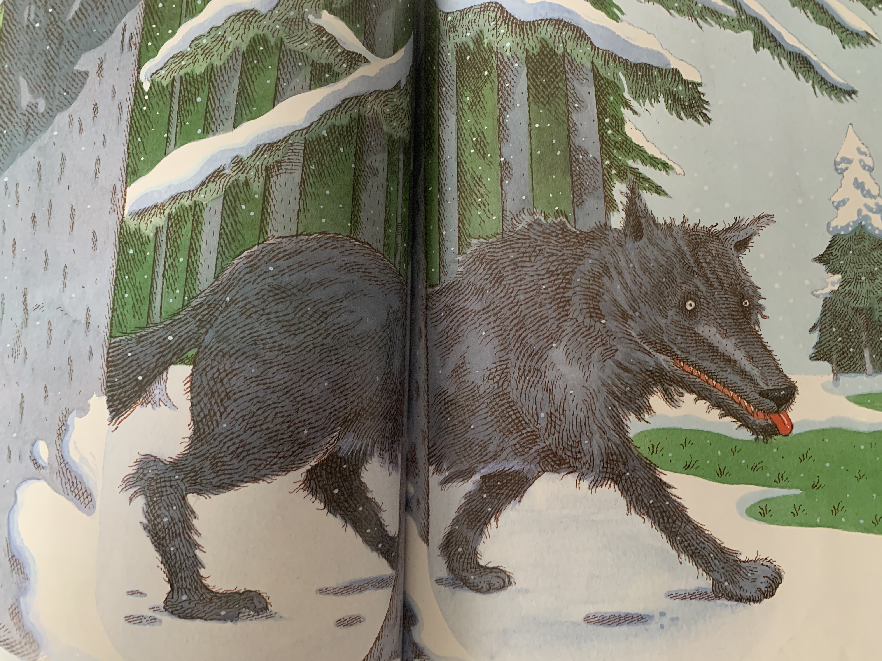 | No sooner had Peter gone, then a big grey wolf came out of the forest.

