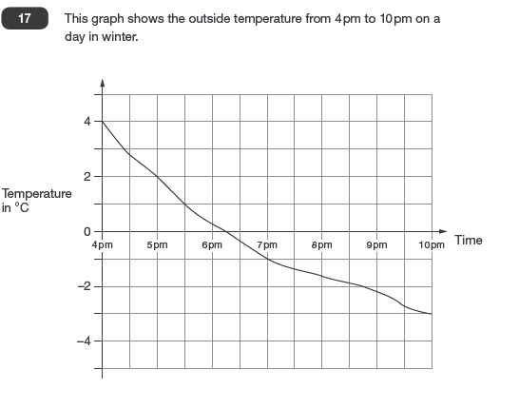
Learning intention - Interpreting Line Graphs 2

a) What was the lowest temperature recorded on the chart?
b) By how much did the temperature decrease in the first hour?
c) At what time did the temperature reach freezing point?
d) How far did the temperature drop between 4pm and 10pm?
e) Estimate the temperature at 7.30.
f) Estimate the time when the temperature was exactly -2.
g) For how long was the temperature below 0?
h) During which hour did the temperature fall by 2 degrees?

