|  |  |
| --- | --- |
| Page 1 Emoticon | Page 2 emoticon |
| Word | Word |
| Page 3 emoticon | Page 4 emoticon |
| Word | Word |
| Page 5 emoticon | Page 6 emoticon |
| Word | Word |

Word bank

glum upset brave worried determined proud petrified terrified frightened relieved

emoticon examples

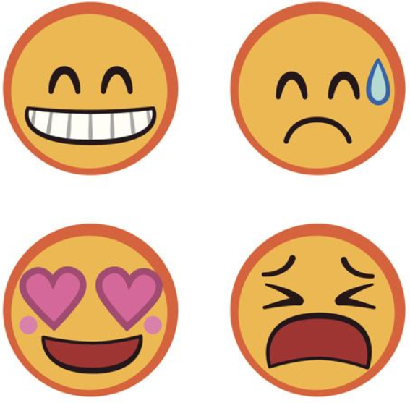 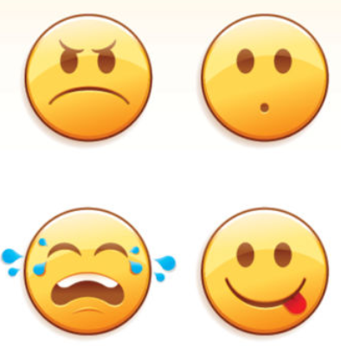 You could find some more or think of your own.