Maths – Short multiplication
Use your knowledge of multiplication to solve these problems.
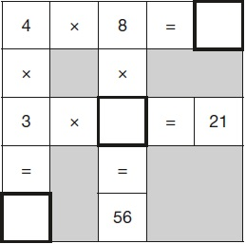
Q1.
In this grid, there are four multiplications.
Write the three missing numbers.

Q2.
Ken buys 3 large boxes and 2 small boxes of chocolates.
Each large box has 48 chocolates. Each small box has 24 chocolates.
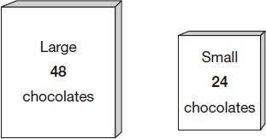
How many chocolates did Ken buy altogether?

Q3

Write the missing numbers to make this multiplication grid correct.
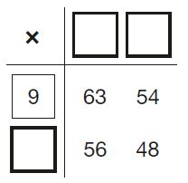

Q4.

Chen uses these digit cards.
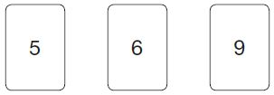
She makes a 2-digit number and a 1-digit number.
She multiplies them together.
Her answer is a multiple of 10
What could Chen’s multiplication be?
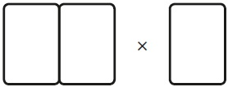
Q5.

Fill in the three missing whole numbers in this calculation.
Each number is less than 10

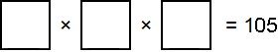
Q6.

Write the missing numbers.

57 | + | 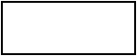 | = | 125

5 | × |  | = | 175
Q7.

A pack of paper has 150 sheets. 4 children each take 7 sheets.
How many sheets of paper are left in the packet?

