Day Five – Solving Word Problems
Q1.
These two shapes have the same perimeter.
regular hexagon square
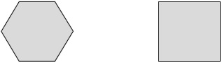
Not actual size
The length of each side of the hexagon is 8 centimetres.
Calculate the area of the square.

Q2.

Here are five triangles on a square grid.
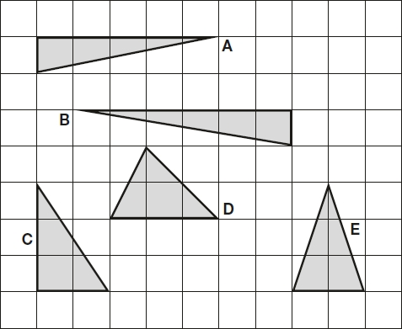
Four of the triangles have the same area.
Which triangle has a different area?
Q3.

The area of a rugby pitch is 6,108 square metres.
A football pitch measures 112 metres long and 82 metres wide.
How much larger is the area of the football pitch than the area of the rugby pitch?

Q4.

The following quadrilaterals all have a perimeter of 36 cm.
Here is a table to show the length of each side.

Complete the table.
One quadrilateral is done for you.

 | Side lengths
square | 9 cm 9 cm 9 cm 9 cm
rectangle | 3 cm
rhombus | 9 cm
kite | 10 cm
Q5.

Megan says,
‘If two rectangles have the same perimeter,
they must have the same area.’
Is she correct?
Circle Yes or No.
Yes / No
Explain how you know.

