1 More Than
Use these numbers to help you. Draw the object in the box.

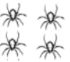
1 more than 4 =


1 more than 1 =


1 more than 3 =

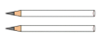
1 more than 2 =

