Day Five – Using your knowledge on light, answer the following questions.
Q1
Shadows
(a) Josh is investigating shadows. He places a block on the floor. He holds a lamp and looks at the shadow the block makes.
(i) Look at the pictures below.
Which picture shows the correct length and direction of the shadow made by the block?
Tick one.
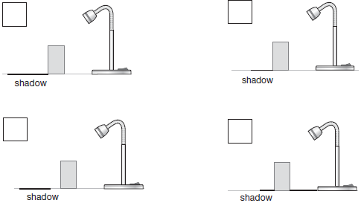

1 mark
(ii) Why does a shadow form when Josh shines the light on the block?
 |  | Tick one.
 | The block is grey and shiny. | 
 | The block is smooth and rigid.
 | The block is solid and opaque.
 | The block is hard and transparent.
1 mark
(b)
Josh investigates if the distance he puts the lamp from the block affects the length of the shadow on the floor.  Josh records his results in the table below. | 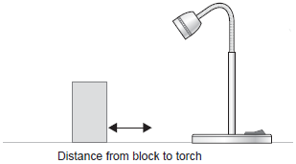

Distance of lamp  from block (cm) | Length of block's  shadow (cm)
5 | 7
10 | 9
15 | 12
20 | 14
25 | 17
Describe the relationship between the distance of the lamp from the block and the length of the shadow.
1. ...................................................................................................................
2. ....................................................................................................................
1 mark
(c) Josh found out that the distance of the lamp from an object does affect how long the shadow is.
He wants to find out more about how to change shadow size.
Suggest another investigation that Josh could carry out using the same lamp and block to find out more about how the size of a shadow changes.
1. ...................................................................................................................
2. ....................................................................................................................
1 mark

Q2.
Road safety

(a) | Julia has a bike with a light.  The picture below shows the  circuit in Julia’s light.  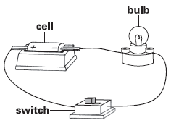 | 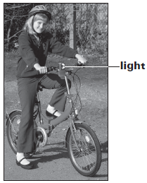
(i) Draw a circuit diagram to show the circuit in Julia’s light.
Use symbols in your drawing.
2 marks
(ii) What should Julia add to her circuit to make the light brighter?
Julia should add .........................................................................
1 mark
(b) It is important for people riding bikes to be seen in the dark.
The pictures below show what two jackets look like when Julia shines
a torch on each of them.
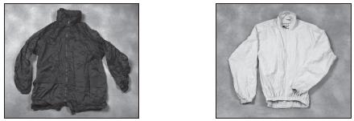
Jacket A Jacket B
Julia can see jacket B better than jacket A.
Explain what happens to the light from the torch for Julia to see jacket B
better than jacket A.
.................................................................................................................
.................................................................................................................
1 mark
(c) Julia’s house is near a bend in the road. There is a mirror on a pole so car drivers can see people coming round the bend.
Draw TWO arrows on the diagram below to show the direction light travels for the car driver to see the light on Julia’s bike.
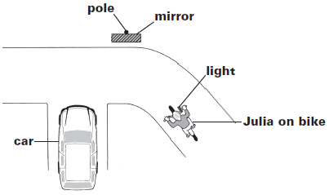
2 marks

Q3.
Torch light
(a) Sanna is investigating which materials are good reflectors of light.
She shines a torch on different objects from a distance of 20 cm.
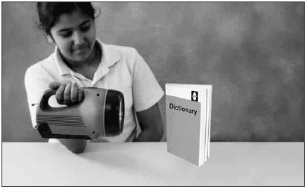
She looks at the objects to see how well each reflects light.
Tick TWO boxes to show which objects are the best reflectors.
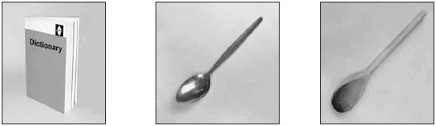
Paper book Metal spoon Wooden spoon


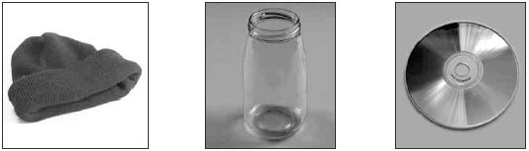
Woolly hat Glass jar Compact disc
2 marks
(b) Tick ONE box to show which of Sanna’s objects does not make a dark shadow.
metal spoon |  | wooden spoon
woolly hat |  | glass jar
1 mark
(c) The picture below shows Sanna looking at the torch light reflected in a mirror.
Draw TWO arrows to show the direction the light must travel for Sanna to see light from the torch in the mirror.
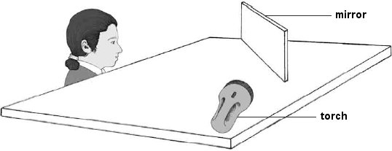
2 marks
Q4.
School play
(a) Polly is in a school play.
She is dressed as a star.  The star costume has bulbs which light up.  The picture below shows the circuit that makes the star light up. | 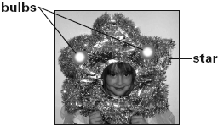
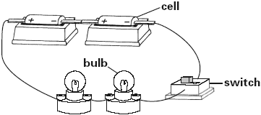
Draw a circuit diagram of the star’s circuit in the space below.
Use these symbols in your circuit diagram.
You can use each symbol more than once if you need to.

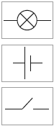
2 marks
(b) Polly wants the star to shine more brightly.
She has some ideas about how she can do this.
Write yes or no next to each idea to show if Polly will see the star shine more brightly.
Idea Will the star shine more brightly?
Yes or no?
add another bulb ......................
add another cell ......................
use longer wires ......................
1 mark
(c) Emma is in the front row at the play.
Draw ONE arrow on the diagram below to show the direction light travels for Emma to see the lights on the star.
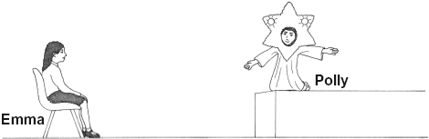
1 mark
(d) Each time Polly appears on stage, Ali hits a triangle.
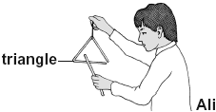
(i) What happens to the triangle for it to make a noise when it is hit?
...............................................................................................................
1 mark
(ii) What does the sound travel through to reach Emma’s ears?
..................................................
1 mark
(e) There are lots of people watching the play. Some people are close to the stage. Some people are further away.
Describe how the distance the people are from the triangle affects the volume of the sound they hear.
........................................................................................................................
........................................................................................................................
1 mark

Q5.
Sea turtles
(a) Turtles live in the sea. They lay their eggs on sandy beaches.
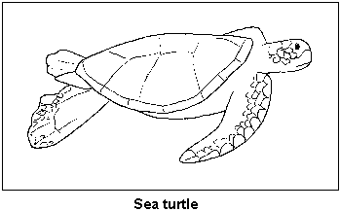
Tick ONE box to show which life process laying eggs is part of.
reproduction |  | growth
nutrition |  | movement
1 mark
(b) Baby turtles hatch from the eggs at night to avoid being eaten by predators.
How could hatching at night help baby turtles to avoid predators?
..............................................................................................................
..............................................................................................................
1 mark
(c) After the baby turtles hatch they go towards the sea. They know which way to go because they can see moonlight reflecting on the water.
Draw TWO arrows on the diagram below to show the direction light travels for the turtle to see the moonlight reflection on the water.
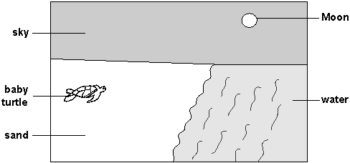
2 marks
(d) Light sources in nearby towns can confuse baby turtles.
They go in the wrong direction towards the town.
If they do not find the sea, the baby turtles may die.
What could people do at night to help the baby turtles to find the sea?
Tick TWO boxes.
turn off street lights  in towns |  | turn off lights on ships
stop cars driving  near the beach |  | open curtains
1 mark
1 mark

