Maths – Multiplying and dividing by 10,100 and 1000 word problems.
Q1
Write the missing number to make this division correct.
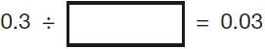
Q2.
﻿
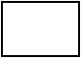 | × | 10 | = | 350.5
460 | ÷ |  | = | 4.6
2.3 | × |  | = | 2,300

Q3.

Write what the four missing digits could be.

 |  |  | ÷ | 10 | = | 3
Q4.

Write in the missing three-digit number.

 |  |  | ÷ | 10 | = | 20
Q5.
Amina’s bed is 190 cm in length and 91 cm in width. She is making a one-tenth scale model of the bed. What are the length and width of Amina’s model?

length = | 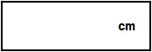
width =
Q6.

A shop sells flowers.

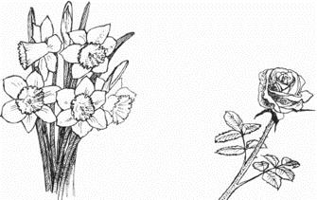
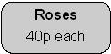
John buys 3 bunches of daffodils.
How much does he pay altogether?
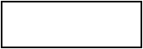
1
Karpal has £4.00 to spend on roses.
How many roses can she buy for £4.00?

