Spelling Wordsearch – Common exception words. (Part 2)

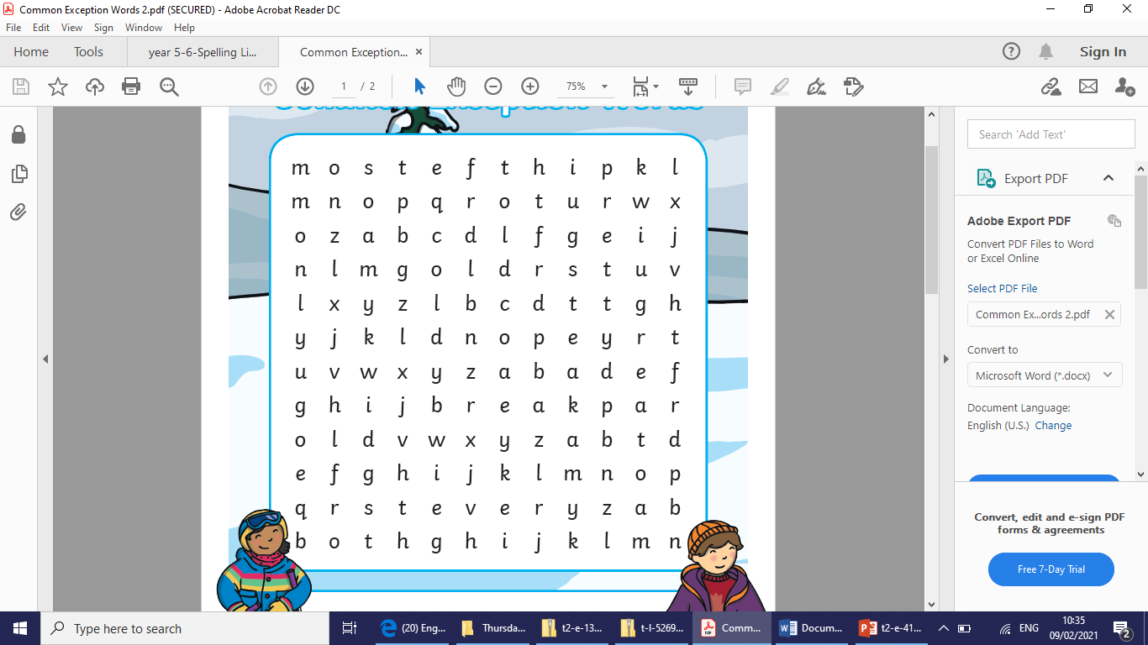

most | cold | great
only | gold | break
both | told | steak
old | every | pretty

