Read time to the nearest minute in analogue and digital.
Draw the hands on the clock to show the time the different sports events start:
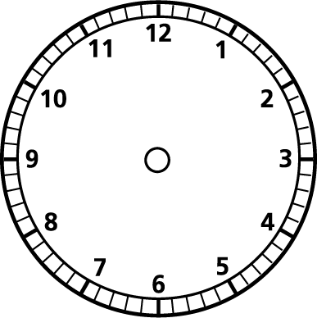
The swimming starts at 9:15 am.

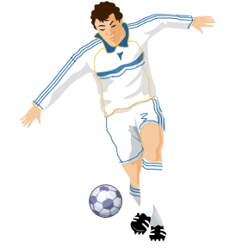
The football starts at 11:03am

The basketball starts at 3:32pm

The horse riding starts at 8:51am

The cycling starts at 2:09 pm.
It lasts for 30min.
What time does it finish? Draw the time on the clock.
