Identifying half and quarter of shapes

Colour 1 half of these shapes.

Colour 1 quarter of these shapes.

Label the shapes whole, half or quarters.

________________ ________________ ________________

Tick which shapes have been split into halves and quarters equally.

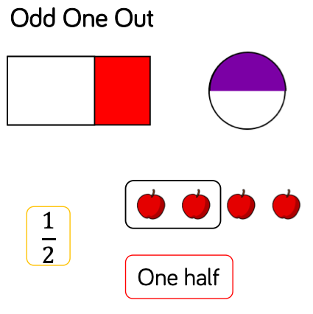
Challenge. Draw a circle around the picture that is the odd one out. Why is it the odd one out?

