Maths - Missing number addition sentences.

Yesterday we learnt how to find the missing numbers in addition sentences to 10. Today, have a go at finding the missing numbers in these addition sentences to 20. I have done the first one for you to remind you. Remember to use the number line to help you if you need to.

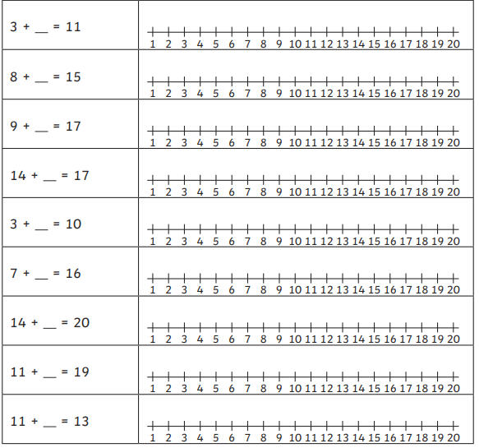

8

4

2

3

5

6

7

818

1