Maths

LO: To multiply by 10

9 x 10 =

57 x 10 =

1.62 x 10 =

20 x 10 =

3.5 x 10 =

893 x 10 =

0.46 x 10 =

63.2 x 10 =

**Always, Sometimes, Never**

If you write a whole number in a place value grid and multiply it by 10, all the digits move one place to the right.

Write what the four missing digits could be.

|  |  |  |  |  |  |  |  |
| --- | --- | --- | --- | --- | --- | --- | --- |
| 4 |  | × | 10 | = |  |  |  |

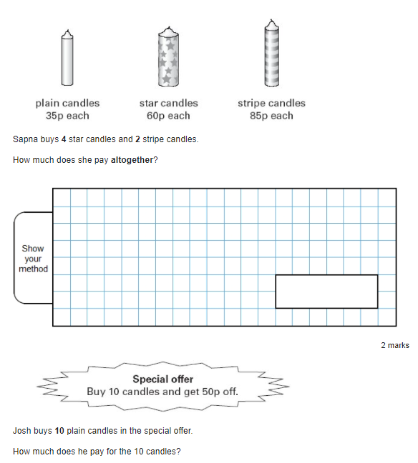

Erika has multiplied a whole number by 10.

Her answer is between 250 and 320.

What could her original calculation be?