The Picts

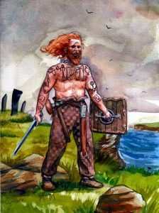

What can you see in the image?

What do you think these people were like?

This is a secondary piece of evidence. What does this mean and why should we be careful when using secondary pieces of evidence?

