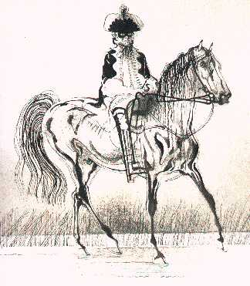
Identifying adverbials

Read each sentence below from the poem ‘The Highway Man’. Can you spot the adverbials?

Sort them into a table with these headings:
- How the action was done or event occurred.
- Where it happened or occurred.
- When it happened or occurred

How the action was done or event occurred | Where it happened or occurred | When it happened or occurred

HINT – underline the main clause to help you spot the adverbials – the main clause will not be part of the adverbials. The first one is underlined as an example.

- Under the moonlit, cloud-swept sky, the highwayman came galloping across the moor.
- Silhouettes of trees flailed their bent arms in the depths of the wood.
- They cast long shadows awkwardly on the rain-soaked ground.
- Owls and bats crossed the woods well after midnight.
- Without a sound, the highwayman’s horse padded across the low dark undergrowth.
- She made her way through the earthy, damp ferns.
- The highwayman’s heart filled him with longing for his girl.
- At long last, the hooves of his proud, sleek mare clattered like a guilty secret on the harsh grey cobblestones.

Now rewrite some of these sentences changing the meaning by changing the adverbials.
Check your sentences for commas which make the meaning clear.

