Art - These are different examples of Aboriginal Art. Aboriginal art is created by the indigenous people of Autsralia. Look carefully at the art an try to answer the questions on the reverse.

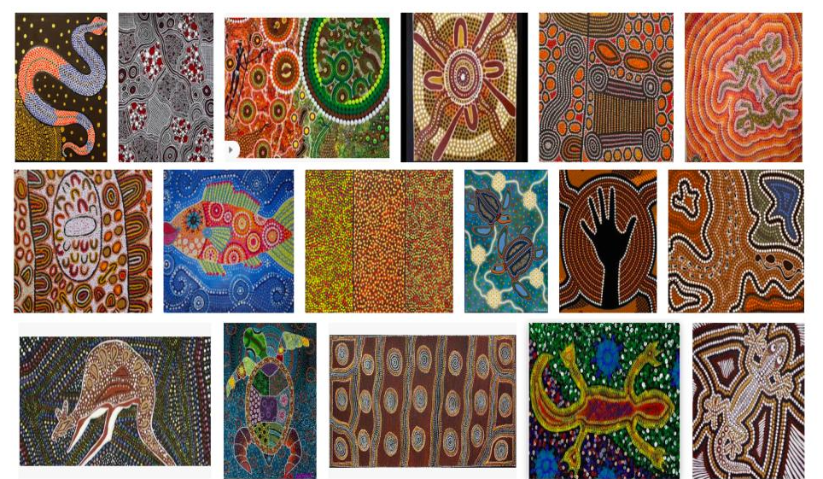

Please turn over to read and answer the questions.

Can you see any patterns and similarities between the pictures?

What do you like about the pictures?

What do you dislike about the pictures?

How do you think they were made? Where might they be from?

