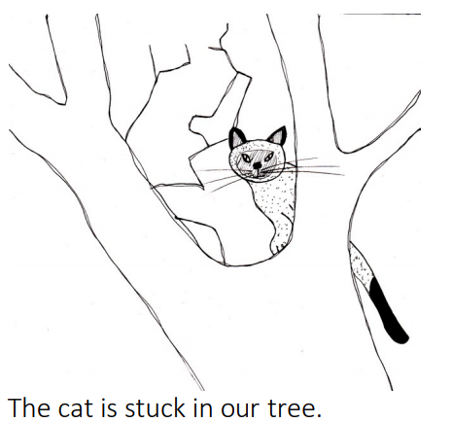
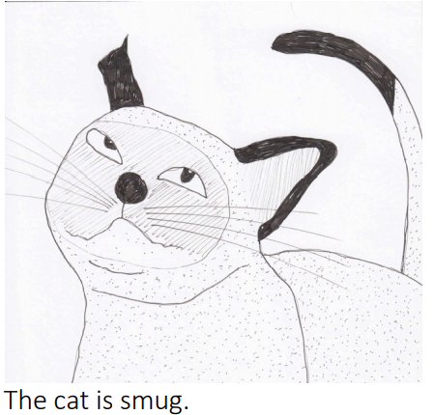
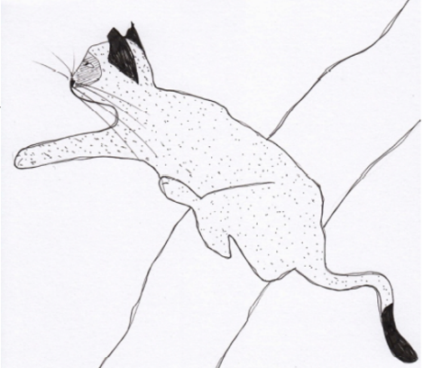
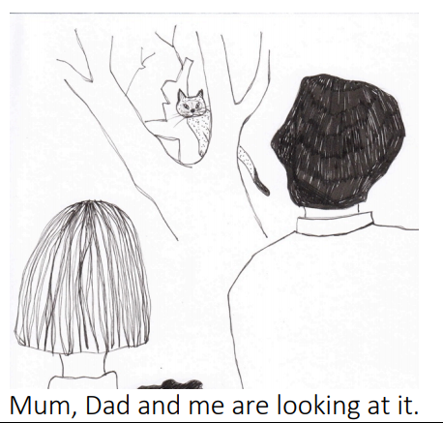
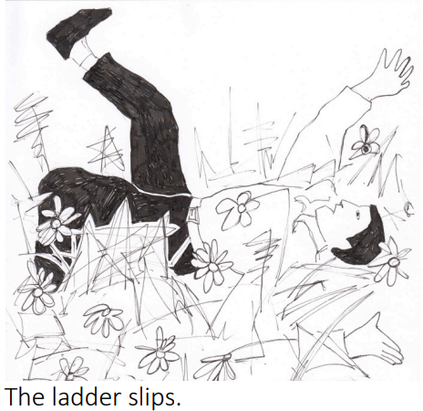
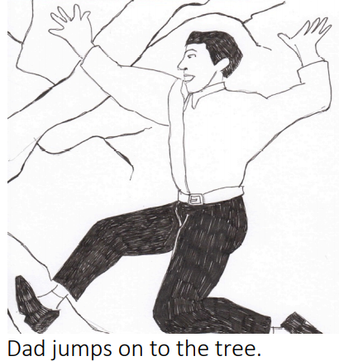
_______________________________________________________________________________________
_______________________________________________________________________________________
_______________________________________________________________________________________
_______________________________________________________________________________________
____________________________________________________________________________________________________________________________________________________
____________________________________________________________________________________________________________________________________________________
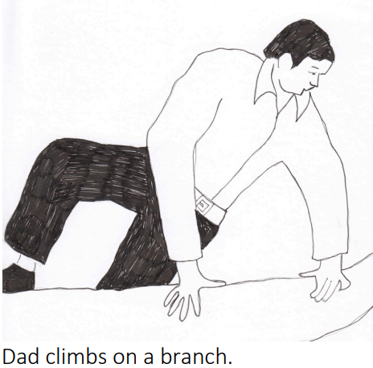
_______________________________________________________________________________________
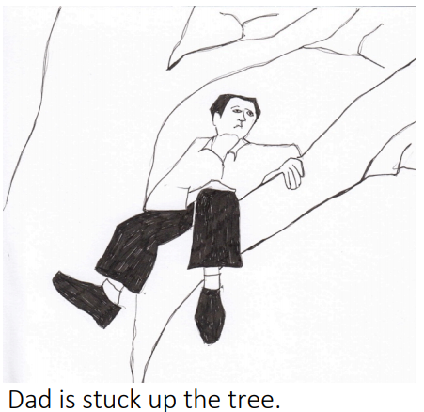
_______________________________________________________________________________________
Monday 1st February
To retell a story.

