English Chapter 8 Alternative 2

Draw an illustration That Roald Dahl could use in the book. You need to show all the different parts of the chapter.
Word bank
farmers tents tractors crater foxes tunnel hole men

Here are some sentences you could use to label the drawing. Add the missing words.
Foxes in a h__________.
Farmers with their t_________ and t_________.
A t_________ to the foxes.
M_____ surrounding the hill.

Don’t forget speech.
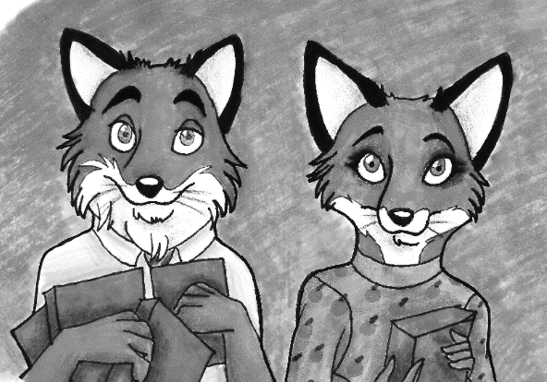
What could the farmers be saying?
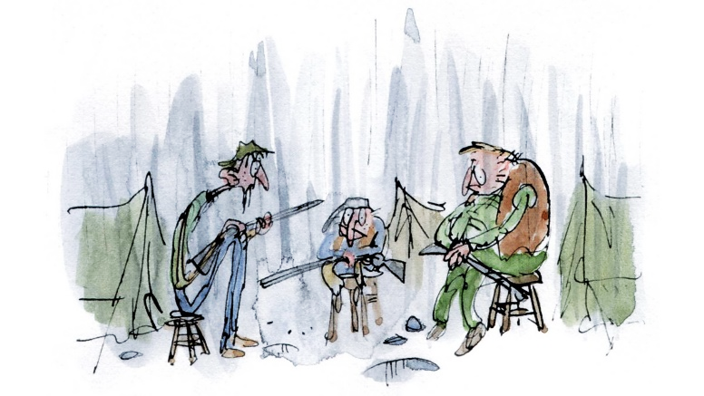
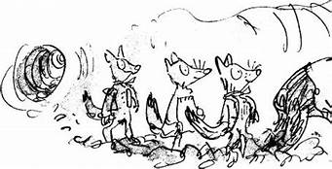
What could the foxes be saying?

Here are some pictures to help.

