Rhyming words in poetry
Use what you have learnt in the PowerPoint, the table and the image to collect rhyming words for a poem about The Highway Man.
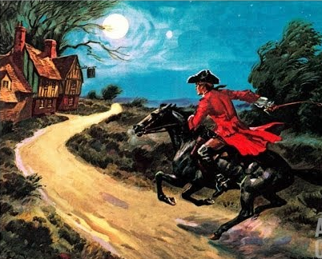

dark | moon | star | man | howl | shot

