English - Rhyming
Draw what could come next in the rhyming string. Can you have a go at writing the words?

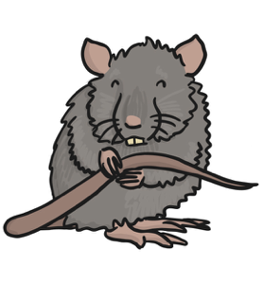
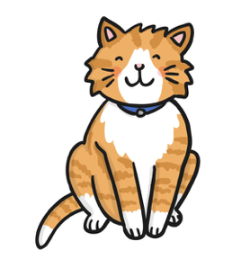

Write the words that would finish the couplets:

I have a pet cat,

It will sit on the __________________.

I had a pet dog,

He is green just like a __________________.

