Tuesday 26.1.21 English.
Look at the pictures and text. What can you find out about the character and story? 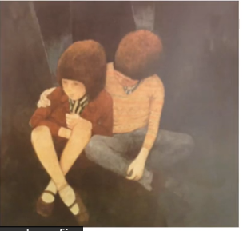
What does this picture tell us about Hansel?

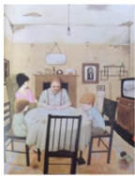
‘The family was always poor’.

What clues show us this?

