Year 2 (Thursday 4.3.21)
Exercise:
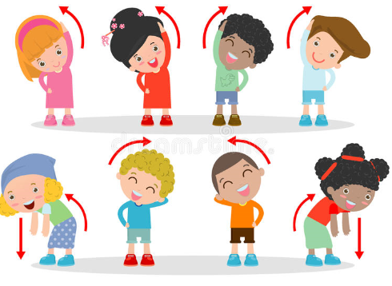
Stretch your arms across your head, one side at a time. Then slowly tilt your head from side to side, then forwards and back. After this gently shake out your whole body and dance for one minute – how many different parts of your body can you move?

English
Learning intention: to plan instructions

Using the PowerPoint and your instructions map from yesterday, add imperative verbs and any ‘Wow!’ vocabulary to your map. This will help you to write your instructions tomorrow.

Alternative learning: Using the PowerPoint and your story map from yesterday, think of any imperative verbs you need for your instructions. Can you add these to your story map then practise saying the instructions? Act them out to help you to remember them.

Spelling: hour sure sugar

Handwriting: Use the PowerPoint to practise writing ‘ure’. Alternative 1: use the PowerPoint to practise writing ‘oo’. Alternative 2: use the PowerPoint to practise writing ‘l’.

Reading
Blue and grey: use your knowledge of the words you have looked at in your reading this week to fill in the gaps on the sheet.
Orange and yellow: read the sheet to discover more about habitats. Pick out three facts that you found interesting and write them in your own words.

Alternative reading
Pink and purple: find the rhymes on the sheet. Remember that a rhyming words sound the same – could you say the words out loud to check if you are right?
Red and green: sound out the words on the sheet then match them to the pictures. Which different sounds can you spot?

Maths
Learning intention: to create a pictogram

Use the PowerPoint to learn how pictures in a pictogram can be used to represent more than one. Remember to look at and use a key to help you! Then complete the questions on the sheet.

Alternative learning: count the objects. Can you draw a circle to represent each one on the pictogram? Remember pictures in a pictogram can be different from the objects they represent e.g. 1 circle could mean 1 apple.

World Book Day
Learning intention: to talk about books we have enjoyed

Have a look at the quiz on the PowerPoint and the emoji quiz on the sheet. Can you answer the questions and find out the book titles? Which ones have you read? Can you remember what happens in some of the stories?

Extra challenge: Have a think about your favourite books you have read recently. Could you write a short review (about 3 sentences) telling me what was so good about it and why I should choose to read it?

Alternative learning: Use the pictures on the sheet to find out the book titles. Which ones have you read? Can you retell your favourite one to an adult?

Remember school website is:http://www.moorside.newcastle.sch.uk/website
If stuck or want to send completed work then email linda.hall@moorside.newcastle.sch.uk

