Blue and grey
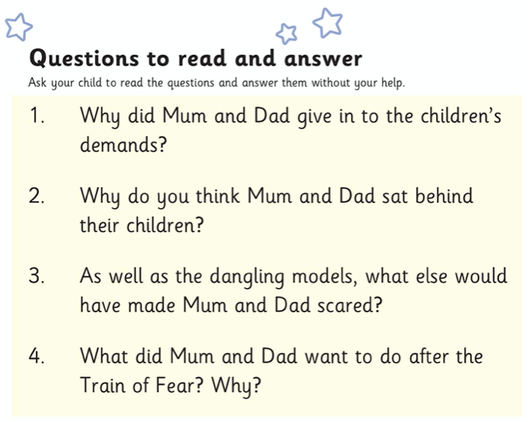

Write a book review for the story. Try to make it about three sentences long. Tell me:
- Your favourite part of the story
- If you liked or did not like the story (and why)
- Whether you think your friend should read the story (and why)
What mark you would give the story out of 10
________________________________________________________________________________________________________________________________________________________________________________________________________________________

__ / 10

