Alternative handwriting

Say the sound, then trace over the letters.

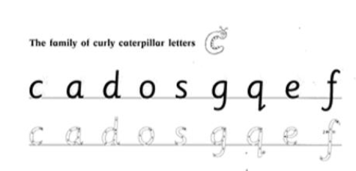
Now practise writing each letter on the lines below.
c________________________
a________________________
d________________________
o________________________
s________________________
g________________________
q________________________
e________________________
f________________________

