1.2.21 Alternative English
Read the red words on the PowerPoint to help you with this reading task. You can listen to the teacher say them if you need some help.

You should then be able to use your phonics skills to read the sentences below. You can use the dots and dashes to sound out some of the words. If you are really stuck an adult could help you. Have a think about what each sentence is saying about then match the sentence to the character who might have said it.

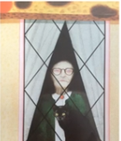
Who said it?

We have lost the kids.

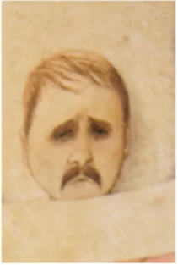

Shall we have some? It is yum.

I will get you fat.

I think you are a bad witch.

