Year 2 (Wednesday 10.2.21)
Exercise: Stretch your arms across your head, one side at a time. Slowly tilt your head from side to side then forwards and back.
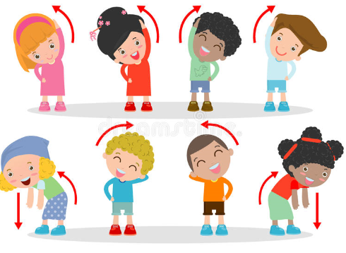
English
Learning intention: To know different word types including verbs.

Look at the PowerPoint about word types. Recap nouns, adjectives, verbs and adverbs. Can you find the types of words in a sentence? Write three sentences about the image, making sure you use at least one word of each type.

Alternative 1: Look at the PowerPoint about nouns and verbs. How many nouns and verbs can you think of to go with the pictures?
Alternative 2: Look at the PowerPoint about verbs. How many verbs can you think of to go with the pictures?

Spelling: any many busy

Handwriting
Practise ‘u-e’ using the PowerPoint. Alternative 1: practise ‘oo’ using the PowerPoint. Alternative 2: practise ‘i’ using the PowerPoint.

Reading
Blue and grey: Read ‘weather around the world’ and answer the questions.
Orange and yellow: Read the diary entries about North America and answer the questions.
Alternative reading
Pink and purple: Read the common exception words on the worksheet. The words do not follow our normal phonics rules. We have looked at these before but you may need an adult to read these with you for the first time. Next find the words in the word search.
Red and green: Read the common exception words on the worksheet. We have looked at these before but you may need an adult to read these with you for the first time. Next find the words in the word search.

Maths
Learning intention: To order and arrange combinations of mathematical objects in patterns and sequences.

Look at the PowerPoint about patterns in 3D shapes. Complete the worksheet.

Alternative 1: Look at the alternative 1 PowerPoint about patterns in shapes. Complete the alternative 1 worksheet.
Alternative 2: Look at the alternative 2 PowerPoint about patterns in 3D shapes. Complete the alternative 2 worksheet.

Music
Learning intention: To identify instruments used in the 1960s and 1970s.

Look at the PowerPoint about 1960s and 1970s music. Which instrument do you like the most? Draw a picture of the instrument and explain why it is your favourite.

Alternative 1: Look at the PowerPoint about 1960s and 1970s music and complete the task.
Alternative 2: Look at the PowerPoint about 1960s and 1970s music. What music do you like? Is it the same or different to what you have heard today? Talk to an adult about anything new that you can hear.

Remember school website is:http://www.moorside.newcastle.sch.uk/website
If stuck or want to send completed work then email linda.hall@moorside.newcastle.sch.uk

