English- Hot seating

Today you are going to play the role of different characters from Fantastic Mr Fox (chapters 1-3).
Have a look at the list of characters below and get into character by imagining you are that person.
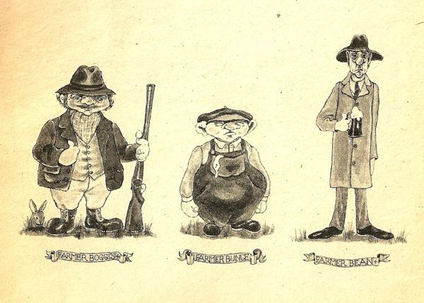

Mrs Fox Mr Fox Boggis Bunce Bean Mr and Mrs Fox’s children

Now get into your hot seating character and ask someone at home to read you these questions. Remember to use your voice in different ways for the different characters. Try to play the role of as many of the different characters as possible.
Are there any other questions you would ask the characters? Add these to the bottom of the list. Try to think of 2 more questions for each character.

Questions for Mr fox | Questions for Mrs Fox
1. How do you feel about the farmers?  2. How did you meet Mrs Fox?  3. How do you feel when you go out at night to get food?  4. Why do you think the farmers shot your tail?  5. What is your favourite meal? Why?  6.__________________________________  __________________________________  7.__________________________________  __________________________________ | 1. How do you feel about the farmers?  2. How did you meet Mr Fox?  3. How do you feel when Mr Fox goes out for food?  4. Why don’t you and your family move away from the farmers?  5. How do you feel living in the tree now that the farmers know you are there?  6.___________________________________  ___________________________________  7.___________________________________  ___________________________________
Questions for Boggis, Bunce and Bean | Questions for Mr and Mrs Fox’s children
1. Why don’t you like Mr Fox?  2. Why are you unkind and angry?  3. Who is the best farmer?  4. How did you become a farmer?  5. Why did you shoot Mr Fox?  6.__________________________________  __________________________________  7.__________________________________  __________________________________ | 1. How do you feel when your father leaves to get you food?  2. Why do you think the farmers are angry?  3. Why do you think the farmers shot your fathers tail?  4. How do you feel living in the tree now that the farmers know you are there?  5. What is your favourite meal? Why?  6.__________________________________  __________________________________  7.__________________________________  __________________________________

