Name

Trace over the number with a pencil.

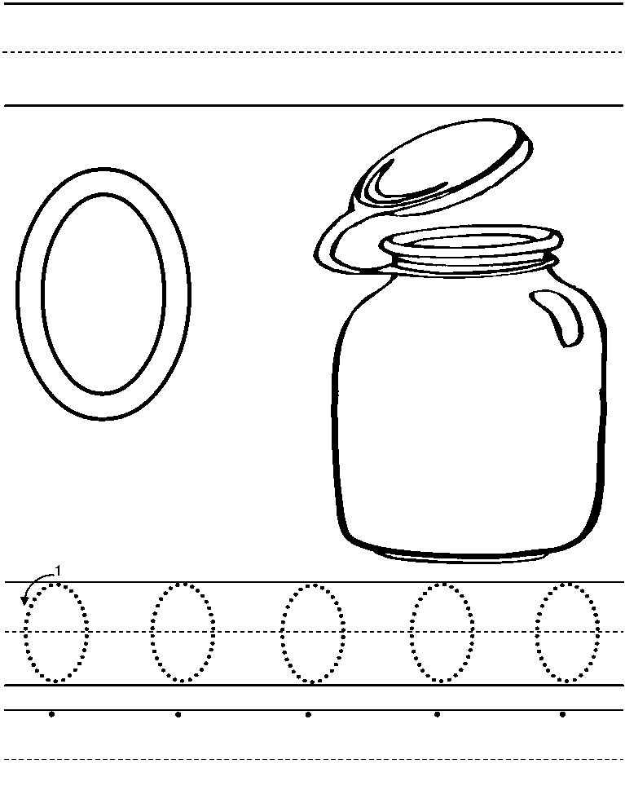

Name

Trace over the number with a pencil.

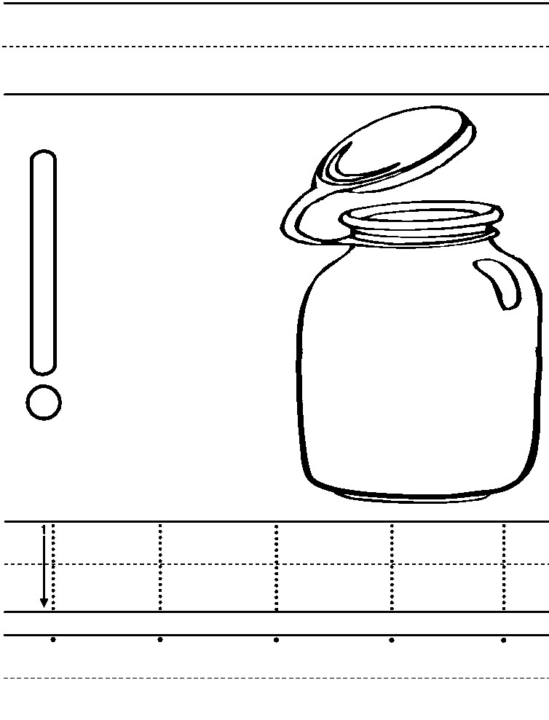

Name

Trace over the number with a pencil.

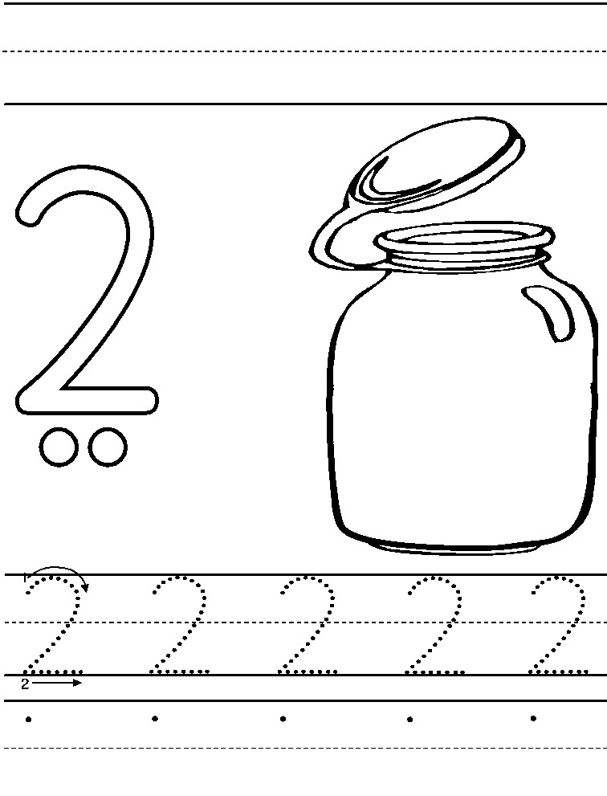

Trace over the number with a pencil.

Name

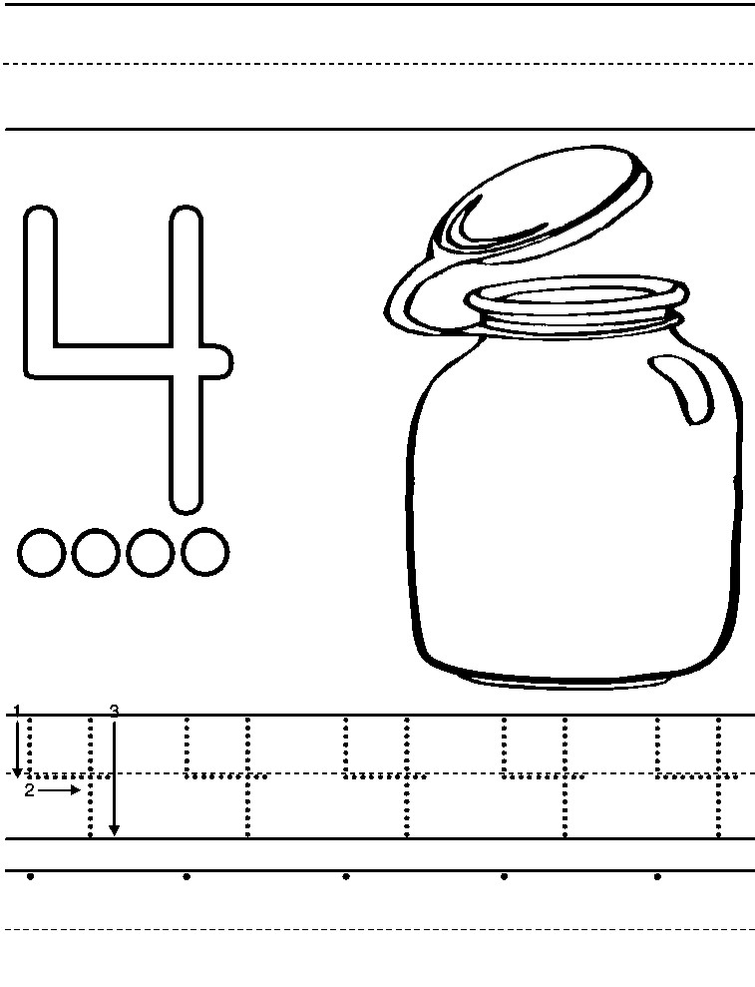

Trace over the number with a pencil

Name

