Maths Alternative 2
- 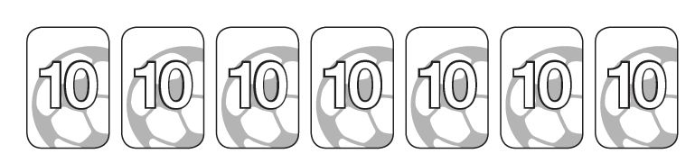
How many cards altogether?

- Match the words to the correct numbers
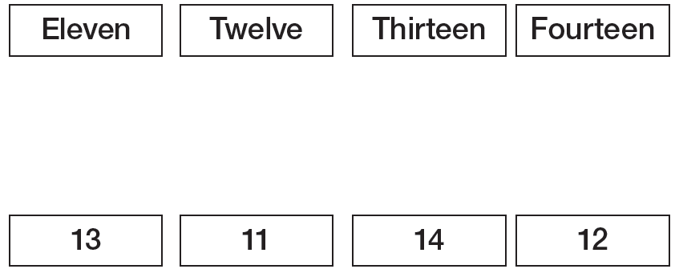

- Sam makes these numbers.
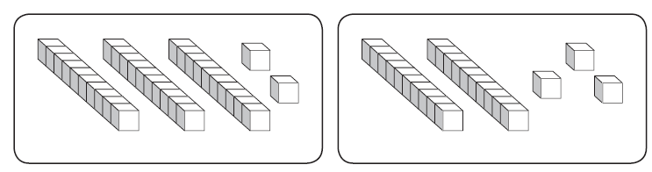
What numbers has he made? _______
Which is greater? Complete the sentence

- Here is a part whole model.
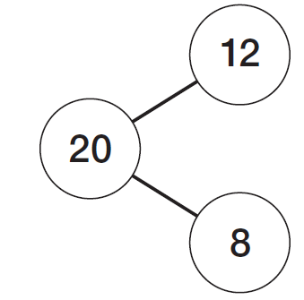
Write the number sentences
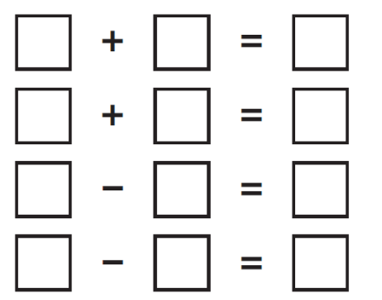

- Anna is counting up in 10s. She starts with 12. Find the next numbers.
12, ___, _____, 42.

- Tom has these marbles.
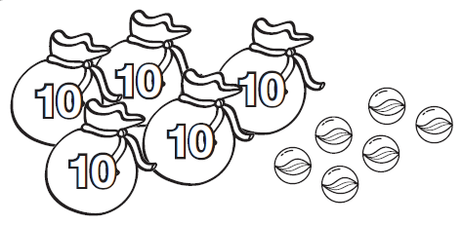
These are Sam’s marbles.
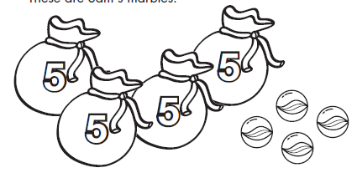
How many more marbles does Tom have?

- Match the same answers.
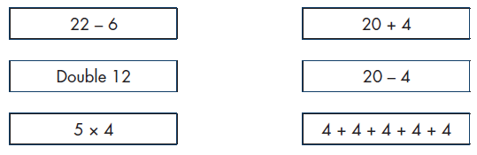

- Show where these numbers go on the numberline.

