Maths : To describe a position
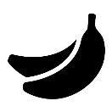
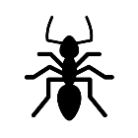
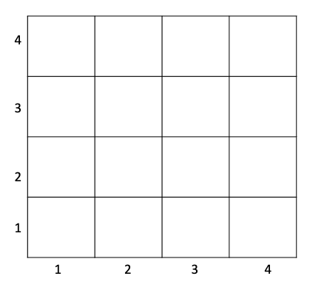
Where are each of the objects?
The ant is …… across and ……. up.
The apple is …… across and ……. up.

The astronaut is …… across and ……. up.

The baby is …………………………………………………………….

The banana is …………………………………………………………….

Challenge: Can you draw your own picture onto the grid then tell me its position?

