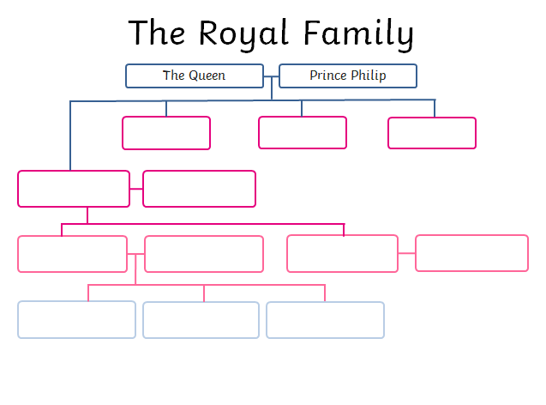

Learning intention: to place people in history on a timeline.