Year Two English
Features of instructions
Use the PowerPoint to remind you of the features of instructions. You can listen to the teacher read the first part of the story or read it by yourself here.
Can you spot the features of instructions in the text? How many instructions can you find? Remember that not every sentence here will be an instruction. When you are finished, have a think about what might happen next in the story.
Instructions
By Neil Gaiman
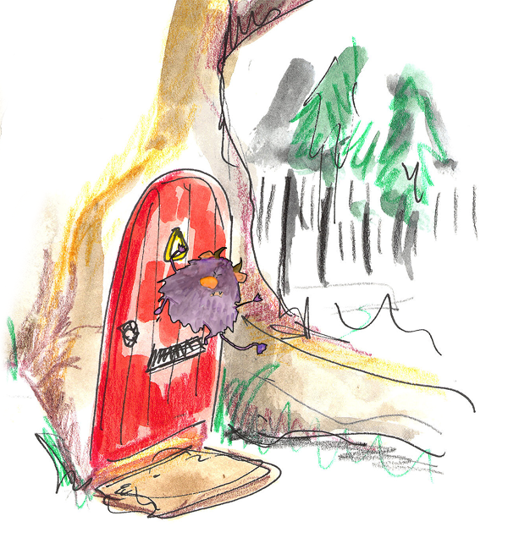
Touch the wooden gate in the wall you never saw before, say “Please” before you open the latch, go through, walk down the path.
A red metal imp hangs from the front door, as a knocker. Do not touch it – it will bite your fingers.
Walk through the house. Take nothing. Eat nothing. However, if any creature tells you that it hungers, feed it. If it tells you that it is dirty, clean it. If it cries to you that it is hurt, if you can, ease its pain.
From the back garden you will be able to see the wild wood. The deep well you walk past leads to Winter’s realm; there is another land at the bottom of it. If you turn around here, you can walk back, safely; you will lose no face. I will think no less of you.
Once through the garden you will be in the wood. The trees are old. Eyes peer from the undergrowth. Beneath a twisted oak sits an old woman. She may ask for something; give it to her. She will point the way to the castle.
Inside it are three princesses. Do not trust the youngest. Walk on.
In the clearing beyond the castle the twelve months sit, warming their feet, exchanging tales. They may do favours for you, if you are polite. You may pick strawberries in December’s frost.
Trust the wolves, but do not tell them where you are going.

