Understanding the Vikings invasion of Britain
The Vikings invaded Britain in 793AD. There were a number of reasons they came here, and their arrival was not a welcome one. Using the information sheet and the map, on the blank map, locate where the Vikings came from, label it and mark the routes they could have possibly travelled to get to Britain. Then answer the questions below.

Why Did the Vikings Leave Scandinavia?

The word ‘Viking’ comes from the Old Norse word ‘vikingr’ which meant ‘pirate.’ People who went raiding in ships were ‘going viking.’ The people commonly called Vikings were the Norse from Scandinavia (modern Denmark, Norway and Sweden). At home, in Scandinavia, the Norse were mostly farmers, fishermen, crafts people and traders. The Norse people were brilliant at building ships that could sail great distances across stormy seas. They used these ships to travel thousands of miles to trade with countries across the world. It wasn’t long, however, before the Norse traders realised that many of the places they traded with were wealthy and undefended and they began to take what they wanted by force. They began to ‘go viking.’

There are many reasons why so many of the Norse people may have wanted to leave their homes and travel thousands of miles across rough and dangerous seas to loot, plunder and eventually settle and set up homes in foreign countries. Those from Norway travelled to Ireland, those from Sweden travelled to Scotland and those from Denmark travelled to England. One theory is that good farmland was scarce in Scandinavia. Much of the land is either too mountainous, covered in thick forest, or the soil is too sandy. For those Norse families who did have farmland, traditionally only the eldest son would inherit the farm. The younger brothers would have to make their living elsewhere, so they may have chosen the Viking life. Another theory is that wars and power struggles between groups of Norse people would often drive people from their homes. The Vikings were made up of many different groups of people from Scandinavia. These sea-faring warriors not only fought people in Britain and elsewhere in Europe, they fought each other too.

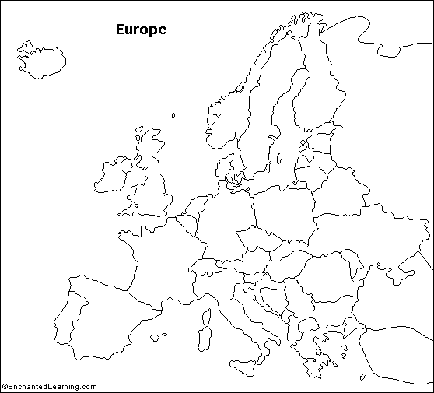

Why did the Vikings come to Britain?
How do you think the Anglo-Saxons (who ruled and lived in Britain) reacted?
Would you say the Vikings were 'pushed' from Scandinavia or 'pulled' to Britain?
How safe was Britain to live in during the 9th century, in your opinion?

