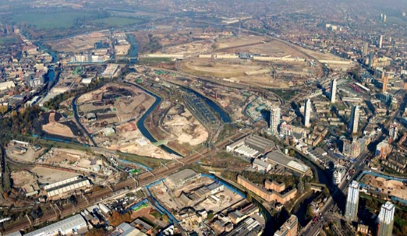
To understand how the human and physical features of East London have changed over time.
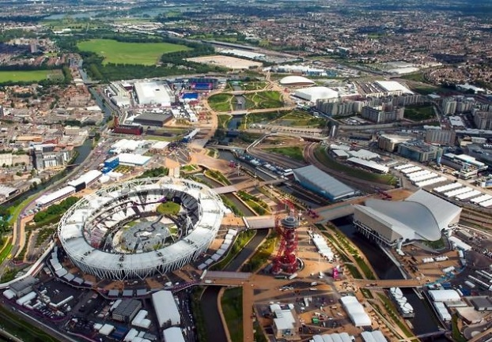
East London 2008 East London 2012

Can you identify changes to the human and physical features since 2008?

Human features | Physical features

What has happened to the population of this area of London?

