Orange and yellow (oo sounds)
Read the alien words containing the ‘oo’ special friends.
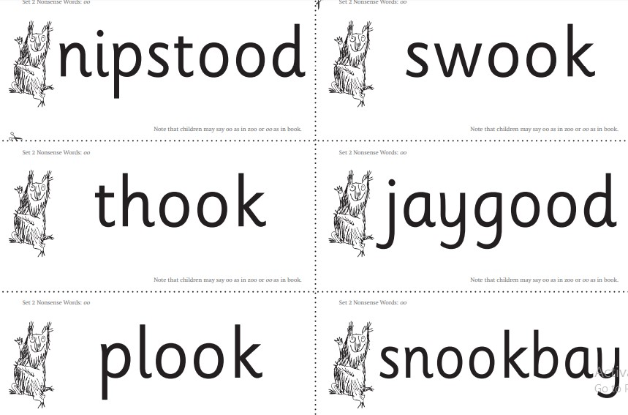

Write the words you read yesterday containing the ‘oo’ special friends.
_ _ _ _ _ _ _ _ _ _ _ _

       

