Alternative English

Talk about these two settings with an adult. These are some of the words you might use.

Can you describe the setting using your own words?

dark

bright

happy

Sad

scary

Colourful

Smell flowers

Warm

cold

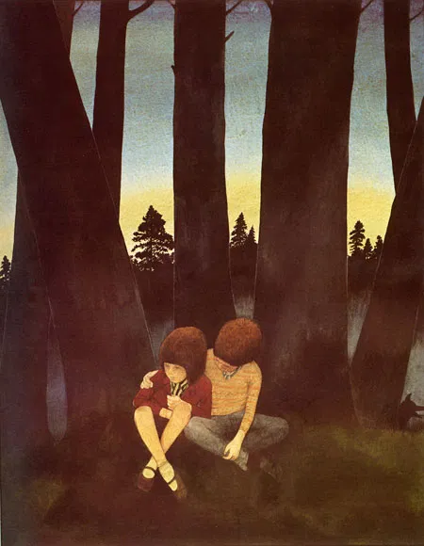 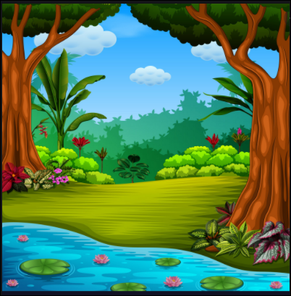

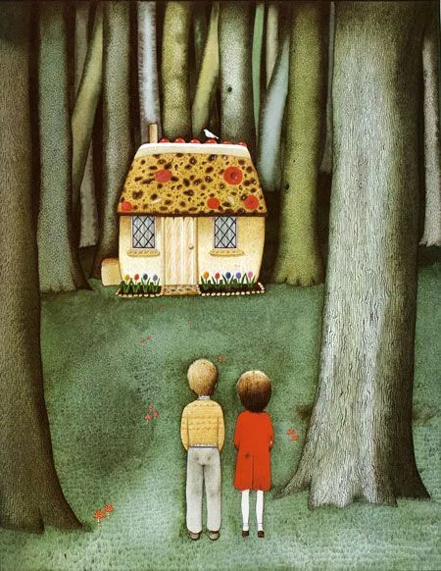 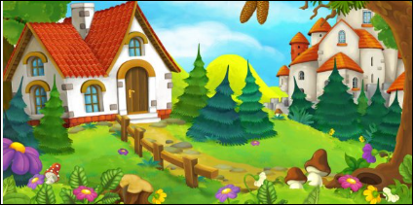

dark

bright

happy

Sad

scary

Colourful

Smell flowers

Warm

cold