Fantastic Mr Fox- Setting map
Re read chapter 2 of ‘Fantastic Mr Fox’ below.
Underline or highlight the parts of the chapter which describe the setting.
Remember the setting is place or surroundings where an event is happening.
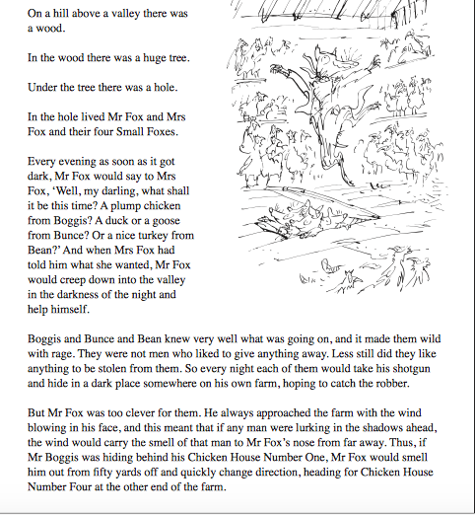
Now use your understanding to draw a map of the setting described in chapter 2. Try to include where Mr Fox and the farmers live, what you know about the wood and the farms.
Can you infer the location of any other buildings/descriptions on the map? For example: Could there be a chicken house 2 and chicken house 3?
Add these to the map as well.
Use these key words to add to your map:

Hill valley tree hole under wood

Behind in end chicken house 1

down Chicken house 4 farm
Fantastic Mr Fox setting map

