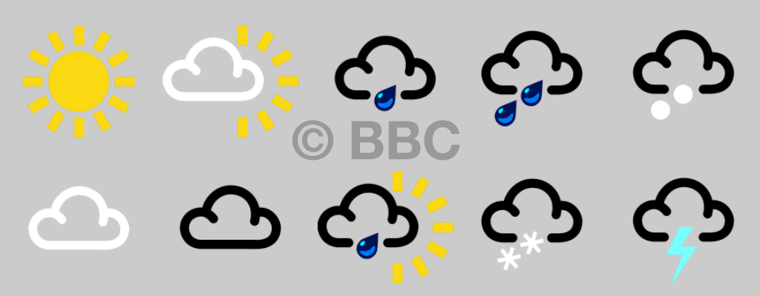
Friday 22nd January - Science
Our Weather Diary

Day
Weather

