Day Four - History – 1950 and now.
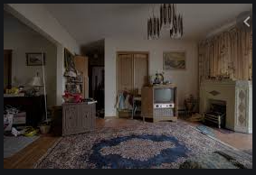
What can you spot that is the same and different in the 2 pictures. Which one is in the 1950s? Which one is now?

