Reading Learning intention – Answer questions about a text using inference and understanding of vocabulary
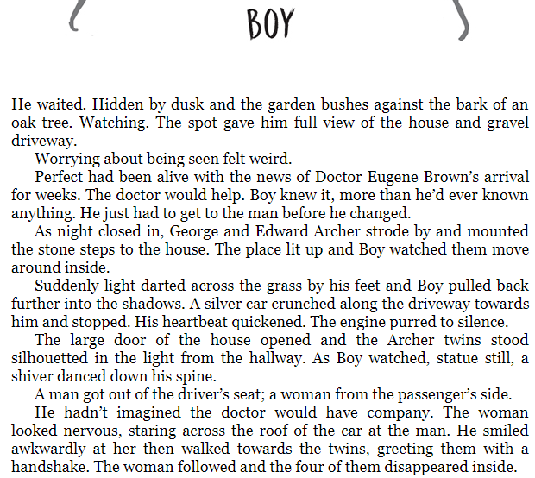
Read the extract of chapter one, ‘Boy’.
1) Clarify what the phrase, ‘Perfect had been alive with the news…’ means.
_________________________________________________________________________________________________________________________________________________________
2) What do you think the Doctor will help with?
_________________________________________________________________________________________________________________________________________________________
3) Find a word in the text which is similar in meaning to a risky manoeuvre.
_____________________
4) Why do you think the girl could be frightened?
_________________________________________________________________________________________________________________________________________________________
Grammar focus
5) Find an example of an adverbial phrase in the text. _______________________________________________
6) Find an adverb in the text. __________________
7) Find an example of parenthesis in the text.
_________________________________________________

